K.V. Kendriya Vidyalaya Dul Hasti Project Kishtwar

WINTER HOLIDAYS HOMEWORK

SUBJECT : SCIENCE

**CLASS: 8TH**

**SYLLABUS COMPLETED:- Syllabus Has been Completed fully.**

**ACADEMICS TASK:**

**Revision of TERM II SYLLABUS TILL LAST CHAPTER:-**

**Chapter 9**: Reproduction in Animals

**Chapter10**: Reaching the Age of Adolescence

**Chapter11**: Force and Pressure

**Chapter12**: Friction

**Chapter13**: Sound

**Chapter14**: Chemical Effects of Electric Current

**Chapter15**: Some Natural Phenomena

**Chapter16**: Light

Revise these above chapters and practice by writing.

* **All students have to complete the exercise (question answers) of each chapter in their SCIENCE homework copies.**
* **LEARNERS DAIRY: Make your Learners dairy for all the above chapters if not done .**
* **The written part should be done neatly in your handwriting in homework copy.**
* **READ , LEARN and REVISE all the above chapters thoroughly.**
* **Holiday homework, Assignment, Projects, Activities is a part of internal assessment so please do it carefully and well before time.**

**ASSIGNMENT: FOR PRACTICE**

**CRITICAL AND CREATIVE THINKING TEST ITEMS**

**PUT SEPARATE CCT SCIENCE NOTEBOOK** .

* WRITE ALL THE CCT QUESTIONS ANSWER NEATLY AND IN WELL PRESENTED WAY IN YOUR CCT NOTEBOOK.

**ENDOCRINE SYSTEM -Practice Test Item-1**

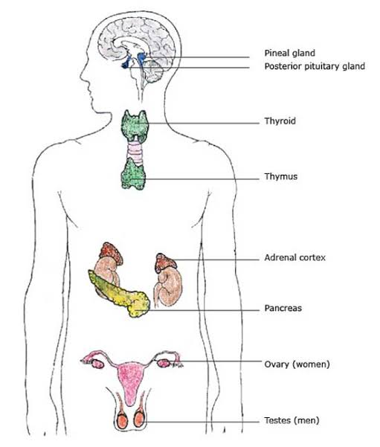

**Which gland….**

a) releases insulin to lower blood sugar levels? ______________________

b) increases your alertness and blood pressure? _____________________

c) helps your growth regulation___________________________________

d) is located at top of your kidneys? _______________________________

e) are found in your brain (two answers)? ___________________________

f) is considered your body’s thermostat? ____________________________

g) perform dual function as endocrine and exocrine gland ______________

h) is temporary and present only in females _________________________

i) is part of digestive system ______________________________________

j) is present in two pairs ___________________________________________

k) need iodine to function properly ____________________________

L) release male sex hormone _______________________________

m) regulates blood Ca++ level ________________________________.

**CHAPTER-14 : CHEMICAL EFFECTSOF ELECTRIC CURRENT**

**Conductors and insulators**

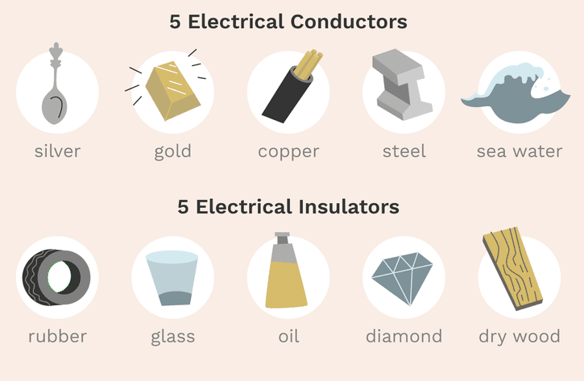

**Figure : Conductors and Insulators of Electricity**

* A conductor is any material or substance that allows electricity to flow through it.
* An insulator is any substance or material that prevents the flow of electricity through it.
* Any substance can be called as a conductor of electricity if it allows movement of charges through it.
* The electrons of the conductors can flow freely (they are delocalized) and hence can take electric current through them.
* Insulators do not allow the flow of charges through them because their electrons are tightly packed with their particles.

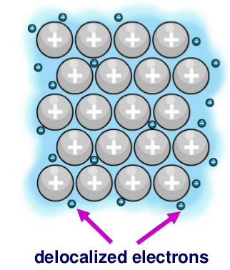

**Figure 2 Delocalized Electrons in a Conductor**

* Some materials can allow a little flow of electricity through them and are called poor conductors of electricity.
* Some materials can allow the complete flow of electricity through them and are called good conductors of electricity.
* Every material may conduct electricity in certain situations. For example, air is a bad conductor of electricity but in case of thunderstorms and lightning it carries electric charges through it. Hence, materials are always classified as good and poor conductors of electricity rather than conductors and insulators.

1.Q.Silver and golds are very good conductor of electricity ,but it is not used in electric wires. Why?

___________________________________________________________________________

2.Q. Why electrical insulators doesn’t conduct electricity?

------------------------------------------------------------------------------------------------------------------------------------

3.Q. Name any two liquids that conduct electricity?

-------------------------------------------------------------------------------------------------------------------------------------

4.Q.Air is bad conductor of electricity ,then how thunderstorms come to the ground?

-------------------------------------------------------------------------------------------------------------------------------------

5.Q.Which of the two is better conductor of electricity.Why?

(a) Drinking water(Tap water). (b) Sea water

**CCT PRACTICE ITEM-2 Topic: Chemical effect of electric current**

**How do liquids conduct electricity?**

* Different substances when mixed in water and electricity is passed through them can break apart and form positive and negative particles or ions in the water.
* These ions can pass the electric current through them.
* The more is the number of ions in a liquid the better conductor it is of electricity.
* That is why distilled water is a poor conductor of electricity but salt water is a good conductor of electricity.
* However, many compounds do not form any ions on mixing them with water and therefore they are poor conductors of electricity such as sugar water, oil and alcohol.

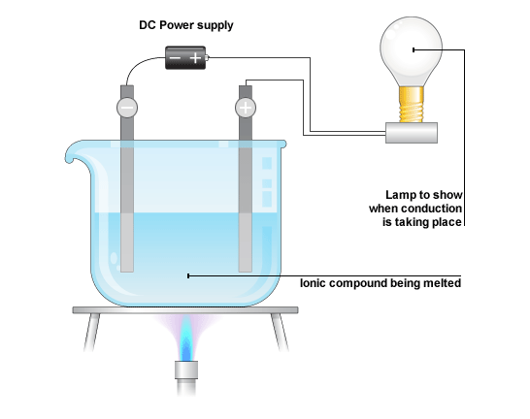

**Fig: Set up to detect if a liquid can conduct electricity**

Q.1.Rain water is a non-conductor of electricity.

(a) True

(b) False

Q.2. A piece of fresh potato doesn’t conduct electricity at all.

(a)True

(b)False

Q.3.Vinegar is a sour liquid .State whether Vinegar will conduct electricity or not.

Q.4.Distilled water doesn’t conduct electricity but tap water conduct some electricity.Why?

Q.5.Most liquids that conduct electricity are solution of ……………………………….……………………………… and …………………………………………………….. .

**CCT PRACTICE ITEM-3 Topic: Chemical effect of electric curren**

**Process of electroplating**

* In order to conduct electroplating right electrodes and electrolytes must be chosen so that metal can deposit over a material.
* For instance, if we want to deposit copper on a material we need an electrolyte that contains copper in it. Similarly, if we need gold on a material we need an electrolyte that contains gold in it.
* Also, we should make sure that the electrode that we are choosing is completely clean.
* The electrodes used are made up of different materials. One of the electrodes is of the same metal of which the electrolyte solution is. The second electrode needs to be the material on which we want to coat another metal.
* For instance, in case we want to plate copper upon brass, one electrode should be of Copper and the other electrode should be of Brass and the electrolyte solution should be any salt which contains copper in it, for example, copper sulphate solution. Consider the diagram given below that describes the process of electroplating of copper.

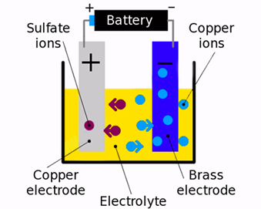

**Figure: Electroplating of copper on brass**

* Out of these two electrodes the copper electrode acts as the anode (positive electrode) and brass electrode acts as the cathode (negative electrode).
* When electricity is passed through the solution, the copper sulphate breaks down into its ions.
* The copper ions (they have a positive charge) get attracted by the brass electrode while the sulphur ions being negatively charged move towards the copper electrode.
* As a result, copper starts depositing on the brass electrode.
* The process of electroplating takes some time to complete.
* The amount of time that it will take depends upon the strength of the current that is being passed through the circuit and also upon the concentration of the electrolyte.
* As these two are increased the speed of the electroplating process also increases.

**Applications of electroplating**

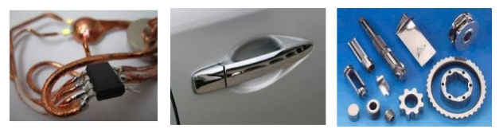

**Figure 7 Electroplated Objects**

* Medical equipment is made up of nickel which is harmful to the human body hence to avoid it from coming in contact with our body a coating of platinum or gold is applied on the surface of nickel.
* Many kitchen equipment’s, bath taps, parts of cars etc. are covered with chromium coating. Chromium is an expensive metal hence the objects are created with the cheaper metal and chromium coating is provided. Thus, to bring a shining over the objects and prevent them from corrosion chromium coating is used.
* Jewellery makers often make ornaments of less expensive metals and provide a coating of gold or silver upon them.
* The tin cans that are used to store food are actually made up of iron and have a coating of tin on them. Iron can easily react with food and spoil it; however, tin prevents the food from getting reacted with iron and therefore helps in preventing it from getting spoiled easily.
* Bridges and various parts of automobiles are made up of iron because it provides strength. However, in order to prevent iron from getting rusted a coating of zinc is provided over it. This method is also called galvanization of iron.

Q.1.Name two metals which are usually electroplated on cheaper metal for making jewellery.

………………………………………………….……………………………………………………………….

Q.2.Name the process in which a coating of one metal can be deposited on the surface of another metal by using current from a battery is called…

……………………………………………………………………………..

Q.3.Why does a brand-new bicycle have shining handlebar and wheel rims?

……………………………………………………………………………………………………………………………………………………

Q.4.For electroplating copper on an iron object, which terminal of the battery is connected to the iron object?Also name the electrolyte you will use for the purpose.

……………………………………………………………………………………………………………………………………………………………

Q.5.Which effect of electric current is utilised when a thin layer of chromium metal is deposited on an iron tap?

………………………………………………………………………………………………………………………………………………………………………………………………………………………………………………………………………………………………………………

**CLASS VIII SUB: SCIENCE CHAPTER-15 : SOME NATURAL PHENOMENA**

**Practice Test Item-1**

**1**. **Answer the questions number 1 (A) to 1(D) based on the understanding of the following paragraphs and the related studied concept.**

Lightning is one of the most beautiful displays we can see in our nature which can certainly be deadly at times. It is a sudden [electrostatic](https://byjus.com/physics/electrostatics/)discharge between the electrically charged regions of the cloud. As we know that it occurs due to electrically charged storms but still the method of charging of clouds remains elusive.

. In 1752, one of the American scientists Benjamin Franklin said that the phenomenon of sparks from the clothes and lightning is the same but people did not agree with him and it took 100 years to realize the truth.

We have seen electric sparks at many places for example sometimes we see electric sparks in electric poles when the wires become loose. We also see sparks in the plug if the connections in the socket are loose. In ancient times people did not understand the cause of lightning, and they thought that it is some kind of wrath of gods which is visiting them.

* Lightning can be explained in terms of charges produced due to rubbing. During a thunderstorm, the air currents move upwards and the water droplets move downwards. And this caused due to the separation of charge due to this vigorous motion.
* As a result of this process, the positive charges collect near the upper edge and the negative charges accumulate near the lower edge of the cloud and also near the ground.
* As the charge gets accumulated, its magnitude becomes very large. Water droplets in the air act as a conductor of this charge.
* These charges flow to meet, thus producing strikes of lightning and thunder. For this phenomenon to occur, a sufficiently high electric potential between two regions and a high resistance medium must be present.

Sometimes lightning may be seen before the thunder is heard and this is because the distance between the clouds and the surface is very long and the speed of light is much faster than the speed of sound and hence lightning can be seen before the thunder is heard. You must know that the lightning frequency is around 40-50 times a second on Earth.

**1 (A) Lightning is caused by-**

(a) The accumulation of magnetic forces in the clouds.

(b) The accumulation of gravitational forces in the clouds

(c) The accumulation of charges in the clouds.

(d) Both a and b.

**(B). Sometimes lightning may be seen before the thunder is heard and this is because-**

(a) The distance between the clouds and the surface is very long

(b) The speed of light is much faster than the speed of sound.

(c) The speed of light is much smaller than the speed of sound.

(d) Both a and b

(**C) Who gave the phenomena of lightning?**

(a) Issac Newton (b) Galileo (c) Benjamin Franklin (d) C.V.Raman

**(D) Which are the groups of natural phenomena?**

(a) cyclones, earthquake, lightning

(b) storms, cyclones, earthquake

(c) storms, lightning, earthquake

(d) all the above.

**Practice Item Test- CONCEPT- Various methods of charging**

**2**. Answer the questions number 2 (A) to 2(D) based on the understanding of the following paragraphs and the related studied concept:

The process of making a neutral body into a charged body is known as **electrification.**Electrification is a universal phenomenon.

A body can be electrically charged by any one of the following three ways.

1. Friction
2. Contact
3. Electrostatic induction

The electricity (i.e. transfer of electrons) that is produced due to friction is called **frictional electricity.**

When we rub two neutral bodies, there will be some transfer of electrons from one body to the other due to structural modifications because of the frictional forces acting on them.

In this method, one of the bodies acquires a negative charge while the other gets a positive charge, both of which are equal in magnitude.

* When a glass rod is rubbed with a silk cloth, glass acquires a positive charge and silk cloth acquires a negative charge. Electrons are removed from glass rod and are added to silk cloth.
* When an ebonite rod is rubbed with fur cloth, ebonite rod acquires a negative charge and fur cloth acquires a positive charge. Electrons are transferred from fur cloth to ebonite rod.

**2. (A). A body can be electrically charged by any one of the following ways:**

(a) Friction (b) contact (c) electrostatic induction (d) all the above

**(B).Types of charges are:**

(a) Positive charge (b) negative charge (c) both a and b (d) None of the above

**(C) When a glass rod is rubbed with a silk cloth, then electrons are removed from glass rod and are added to silk cloth. It results** …

(a) Glass acquires a positive charge and silk cloth acquires a negative charge.

(b) Glass acquires a negative charge and silk cloth acquires a positive charge.

(c) Glass acquires a positive charge and silk cloth also acquires a positive charge

(d) Glass acquires a negative charge and silk cloth also acquires a negative charge.

**(D) When an ebonite rod is rubbed with fur cloth, ebonite rod acquires a negative charge and fur cloth acquires a positive charge**.

(a) Electrons are transferred from ebonite rod to fur cloth

(b) Electrons are transferred from fur cloth to ebonite rod,

(c) Both a and b

(d) None of the above

**PRACTICE TEST ITEM- - 3 TOPIC: Transference of Charge**

**Answer the questions number 1 to 4 based on the understanding of the following paragraphs and the related studied concept:**

Electric charge is capable of being transferred from one body to another if they are connected to each other through a conductor. It takes place due to transfer of free electrons. Direction of flow of charge is governed by the degree of electrification (electric potential) of body. Electrons tend to move from the body having lower degree of electrification (lower potential) to that having higher degree of electrification (higher potential). Algebraic sum of the charges, on the system, remains constant at all times. Transference of charge shall stop when the two bodies have acquired same degree of electrification. It is not possible to transfer whole of the charge on one body to another.

Transference of charge from one body to the other results in change of their masses since the electrons are material particles. An increase in positive charge or a decrease in negative charge results in decrease of the mass of body and vice versa.

1. **When the body is positively charged by friction, it has :**
2. Lost some electrons b) gained some electrons c) neither lost nor gained electrons d) none of the above
3. **When a body is earth connected, electrons from the earth flow into the body. This means the body is:** (level 1)
4. Charged negatively b) an insulator c) uncharged d) charged positively
5. **How can the mass of any object be decreased? ( brief with charge theory )**
6. **What is not true about transfer of charge?**
7. Electrons always move from higher potential to lower potential
8. Transfer of charge happens due to movement of electrons present in the atom.
9. Only option (i)
10. only option (ii)
11. option (i) and (ii) both
12. neither option (i) nor option

**Practice Test Item- 4**

**TOPIC: Charges and their Interaction**

**Answer the questions number 1 to 4 based on the understanding of the following paragraphs and the related studied concept:**

A charge is a fundamental characteristic property of elementary particles of matter which can explain certain forces of interaction and some types of interaction energies. There are well defined pairs of substances which can electrify each other when rubbed together. William Gillbert, who did primitive work on ‘electrification ‘observed that there are two types of electrifications possible. As a result of electrification, one substance acquires a positive charge while the other acquires a negative one.

A body acquires positive charge due to transference of electrons away from it. This results in a decrease in mass of body. Therefore, the body becomes comparatively lighter. A body acquires negative charge due to transference of electrons to it from another body. This results in an increase in mass of body. Therefore, the body becomes comparatively heavier.

Addition of similar type of charges results in net increase of charge while the addition of opposite types of charges results in the net decrease. Charge cannot exist independently. It is independent of the state of rest or motion. Like charges repel each other and unlike charges attract each other.

1. **What happens to the mass of body when it is charged? a) positively b) negatively**
2. **Can an electrically neutral body be attracted by a charged body?**
3. **Choose the correct option**.
4. **A body acquires positive charge when it gets electrons.**
5. **A body acquires negative charge when it loses electrons.**
6. **Addition of positive and negative charges results in the net decrease**.
7. Only option (i)
8. Only option (ii)
9. Only option (iii)
10. Options (i) and (ii)
11. **State true or false :**
12. **A positive charge always attracts a negative charge.**
13. **A negative charge always attracts a negative charge.**
14. **body acquires negative charge due to transference of electrons to it from another body, hence it becomes heavier.**

**Practice Test Item-5 A STORY OF LIGHTENING**

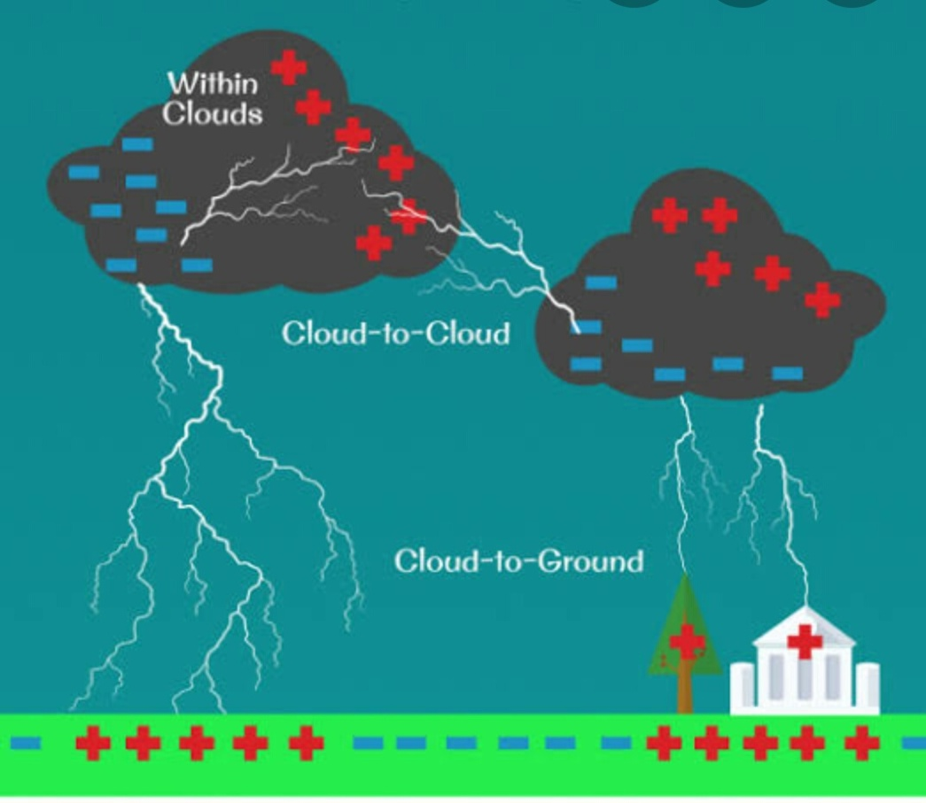

A lightning strike or lightning bolt is an electric discharge between the atmosphere and the ground. They mostly originate in a cumulonimbus cloud and terminate on the ground, called cloud-to-ground (CG) lightning. A less common type of strike called ground-to-cloud (GC) is upward propagating lightning initiated from a tall grounded object and reaching into the clouds. About 25% of all lightning events worldwide are strikes between the atmosphere and earth-bound objects. Most are intra-cloud(IC) lightning and cloud-to-cloud(CC), where discharges only occur high in the atmosphere. Lightning strikes the average commercial aircraft at least once a year, but modern engineering and design means this is rarely a problem movement of aircraft through clouds can even cause lightning strikes. A single lightning event is a ‘flash’, which is a complex, multi-stage process, some parts of which are not fully understood. Most CG flashes only ‘strike’ one physical location referred to as a ‘termination’. The primary conducting channel, the bright coursing light that may be seen and is called a ‘strike’, is only about one inch in diameter, but because of its extreme brilliance ,it often looks much larger to the human eye and in photographs. Lightning discharges are typically miles long, but certain types of horizontal discharges can be upwards of tens of miles in length. The entire flash lasts only a fraction of a second.

**Q1**. A student studies that vigorous movement of air current and water droplet, results in building up charges in the clouds. Which phenomenon might have resulted with the discharge of the built-up charges in nature?

a) earthquake

b) lightning

c) rainfall

d)tornadoes

**Q2**. What are the ideal conditions of lightning strike on ground?

**Q3**.Why is the lightning and root of a tree have similarities?

**Q4.** How can we calculate how many kilometres the storm is away from us?

**Q5.** If air and cloud were good conductors of electricity, do you think lightning could occur? Explain.

**LIGHTNING STRIKES   (MODULE-6)**

**Answer the questions number 1 to 4 based on the understanding of the following paragraphs and the related studied concept:**

The three main kinds of lightning are distinguished by where they occur: either inside a single thundercloud, between two different clouds, or between a cloud and the ground. Many other   observational variants are recognized, including "heat lightning", which can be seen from a great distance but not heard; dry lightning, which can cause forest fires; and ball lightning, which is rarely observed scientifically. Lightning causes thunder, a sound from the shock wave which develops as gases in the vicinity of the discharge experience a sudden increase in pressure. Lightning occurs commonly during thunderstorms and other types of energetic weather systems, but volcanic lightning can also occur during volcanic eruptions

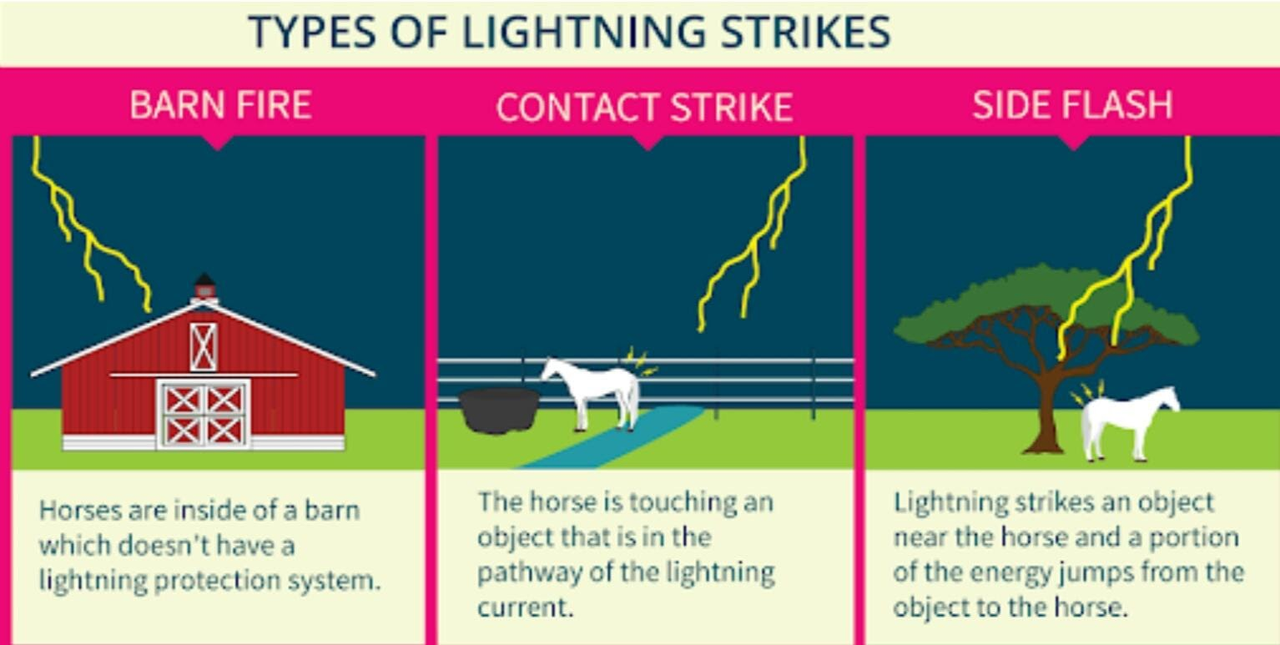

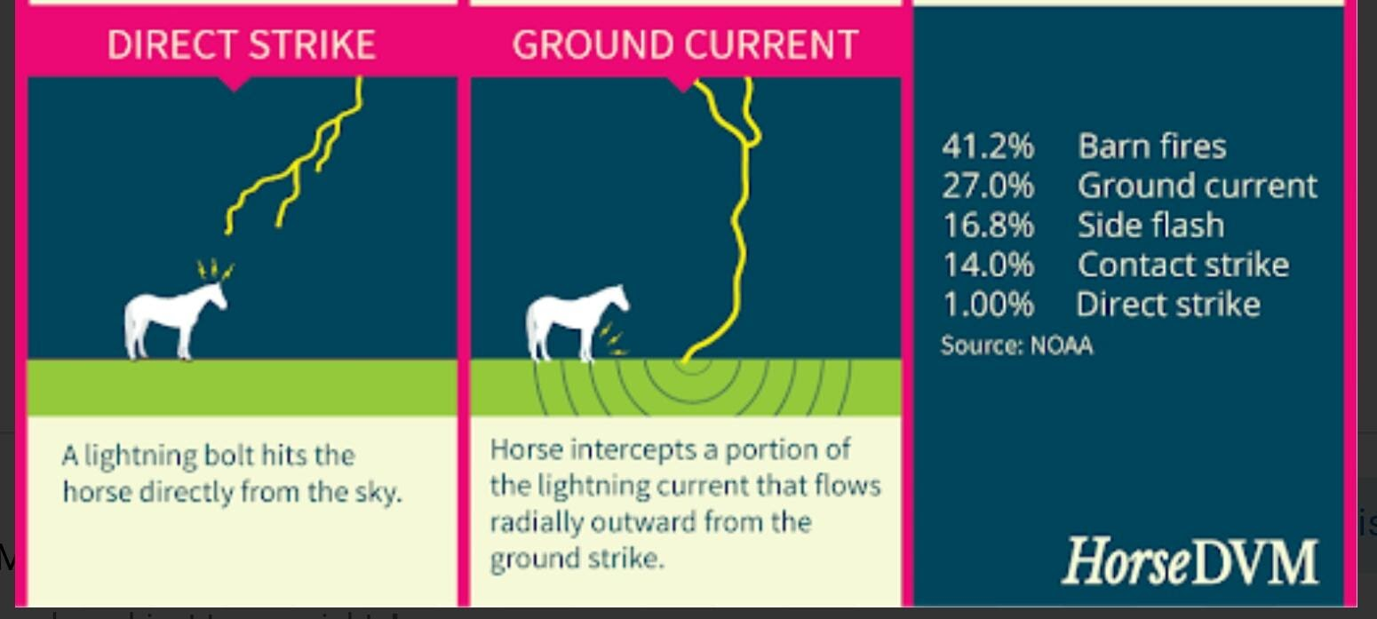

What are Indirect Lightning Strikes? Did you know lightning also strikes the ground beneath your feet?

Indirect lightning strikes, or strikes that discharge their electricity into the ground, aren’t as well-known but they are very powerful. Let’s learn a little more about them so you can protect yourself from every type of lightning strike during the next thunderstorm. You can also protect yourself by using tools, like a lightning alert horn and strobe system powered by a total lightning network.

 Things You Need to Know

1. The difference between direct and indirect lightning strikes

There is one main difference between direct lightning strikes and indirect lightning strikes, and it’s related to the way they travel. A direct lightning strike occurs when all the lightning’s energy is directed through the body or over the body on the skin.

An indirect lightning strike can happen two different ways.

The first way is through a ground current. These occur when lightning strikes an object or the ground and the electricity travels through the ground until it encounters another object.

The second way is through a side flash. This happens when lightning strikes an object that seeks a path that lets it jump through the air to a second object. For example, lightning may strike an airplane on the tarmac and leap through the air as a side flash to hit a nearby ground crew worker, causing serious injuries and even death. Airports face several threats from lightning.

2. Indirect Lightning Strikes Can Kill

According to NOAA, an average bolt of lightning carries 20,000 to 30,000 amperes of charge and about 300 million volts. Direct lightning strikes are more dangerous, but both can be incredibly damaging. Both types of strikes have enough power to kill.

In 2016, an indirect lightning strike that hit the ground in Norway killed over 300 reindeer. The electricity travelled through the ground and killed the animals during a thunderstorm. The total death toll was 323. This is just one of the many examples of the deadly powers of indirect lightning strikes.

3. Indirect Lightning Strikes are More Common in fact direct lightning strikes only make-up about 4% of all reported strikes. Indirect lightning strikes, which produce ground currents, account for about 50% of lightning injuries. Since these strikes happen a lot, it’s a good idea to be prepared for them and know when lightning is in your area.

Lightning is also a very common event. In fact, there were more than 19 million cloud-to-ground lightning strikes in the U.S. alone in 2019.

**Q 1. Which among the following are the tools to protect from lightning?**

i) Lightning alert horn

ii)  Strobe system

iii) GPS System

iv) Richter scale

Choose the right option:

1. i & iv
2. i & ii
3. ii & iii
4. iii & iv

**Q2. Lightning always follows**

a) A thunder

b) Rain pours

c) The easiest path

d) The straight path

**Q3.Why is Lightning Energy yet Untapped?**

**Q4.Why does the sound appears like a hammer hitting the building when a strong lightning occurs between the clouds?**

**Q5.What is thunder? Why is there an interval between lightning and thunder?**

------------------------------------------------------------------------------------------------------------------------------------

**MODULE 7**

**Answer the questions number 1 to 4 based on the understanding of the following paragraphs and the related studied concept:**

**1. Electric energy of the sky**

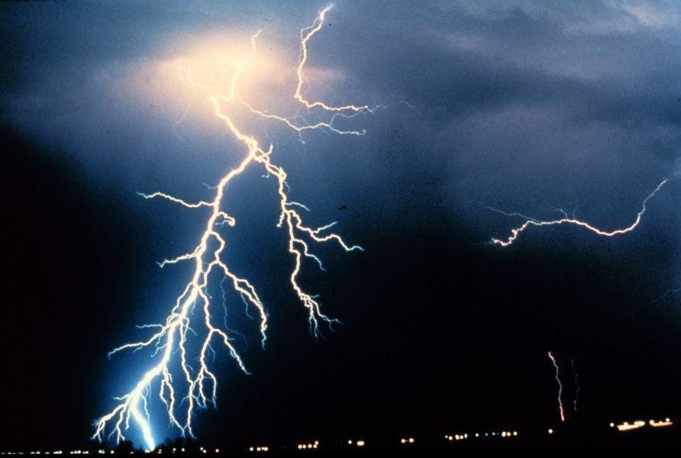

*Given below is a newspaper article published in  : 13 sep 2020*

Chitrakoot, Uttar Pradesh: Three children were killed on Sunday after being struck by lightning in a village in Uttar Pradesh's Chitrakoot district, police said.

The incident took place when the children had gone to the jungle to graze their goats, they said. A man was also injured while his seven goats also died in the incident, the police said.

1. Explain why it is safer to use a wireless telephone instead of a landline telephone during lightning.

2. The weather department has predicted that a thunderstorm is likely to occur on a certain day. Suppose you have to go out on that day. Would you carry an umbrella? Explain.

3. What are the safe places during thunderstorm?  Sitting on motor cycle is safe or not during lightning ?

4. When you are in open where should you take shelter?

5.  A person is in open space during a thunderstorm with no shelter (not even a tree) available nearby. Describe the safe position which he should take to protect himself from lightning. Why is this position safe?

**Practice Test Item-1 MODULE 9**

**TOPIC- EARTHQUAKE (KNOWLEDGE BASED)**

**Answer the questions number 1 to 4 based on the understanding of the following paragraphs and the Related studied concept:**

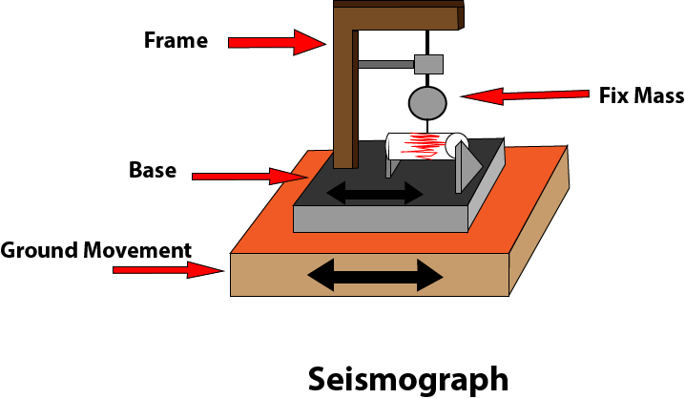

What is a seismograph? A seismograph is an instrument which is used to measure the strength, direction, and duration of [an earthquake](https://inventionsky.com/what-is-an-earthquake/), volcano eruption, explosion, etc.

Facts about Seismograph

1. A sensitive and magnify instrument can easily detect strong earthquake from source anywhere in the world.
2. At seismograph station, the time, location and magnitude of an earthquake or volcano can be easily found out with the help of recorded data.
3. The seismograph is used to detect and record the vibration of the earth surface.
4. The seismograph is also known as a seismometer.
5. Sometimes the series of tremor called [foreshock](https://earthquake.usgs.gov/learn/animations/aftershocks.php) can be felt before the actual earthquake happens. At that time this instrument becomes boon for us.
6. It is also a fact that we cannot predict an earthquake by this instrument.
7. The record generated by seismograph (seismometer) on display or paper print is called seismogram.

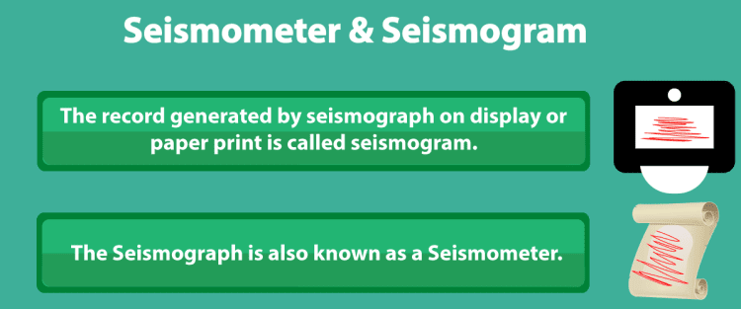

Working of a seismograph

A seismometer consists of a mass hanged to the frame with a fixed base. The seismograph is designed in such a way that when the earthquake happens then, mass remains fix (Due to inertia) but base moves due to the movement of the earth surface.

A magnetic field is created around this hanging mass (Hanging mass is a conductor). When there is no movement, then there will be not any change in the magnetic field.

However, when vibration occurs in the surface due to the movement of the [tectonic plates](https://inventionsky.com/what-are-tectonic-plates/) then base moves, due to which change in the magnetic field takes place, and production of voltage occurs in the hanging mass. This electric voltage is recorded on paper or any other medium.

We know that production of electric voltage will be very less, but there are such precise and accurate instruments by which these small changes can be easily detected and displayed on graphs or any magnetic tape.

**Questions:**

1. **STATEMENT**                                                         T/F

|  |  |
| --- | --- |
| 1. **The tremor waves produce on the surface of the earth are called radioactive waves** |  |
| 1. **A magnetic field can be created if the hanging mass will be insulator** |  |

1. **Differentiate between seismograph and seismogram.**

ANS:-------------------------------------------------------------------------------------------------------------------------------------------------------------------------------------------------------------------------

1. **What causes the generation of voltage in the hanging mass of the seismograph?**

       ANS----------------------------------------------------------------------      ---------------------------------------------------------------------------------------------------------------------------------------------------------------------------------------------------------------

1. **During which particular situation  does seismograph become boon for us?**

ANS-----------------------------------------------------------------------------------------------------------------------------------------------------------------------------------------------------------------------------------

**MODULE 10**

Answer the questions number 1 to 4 based on the understanding of the following paragraphs and the related studied concept:

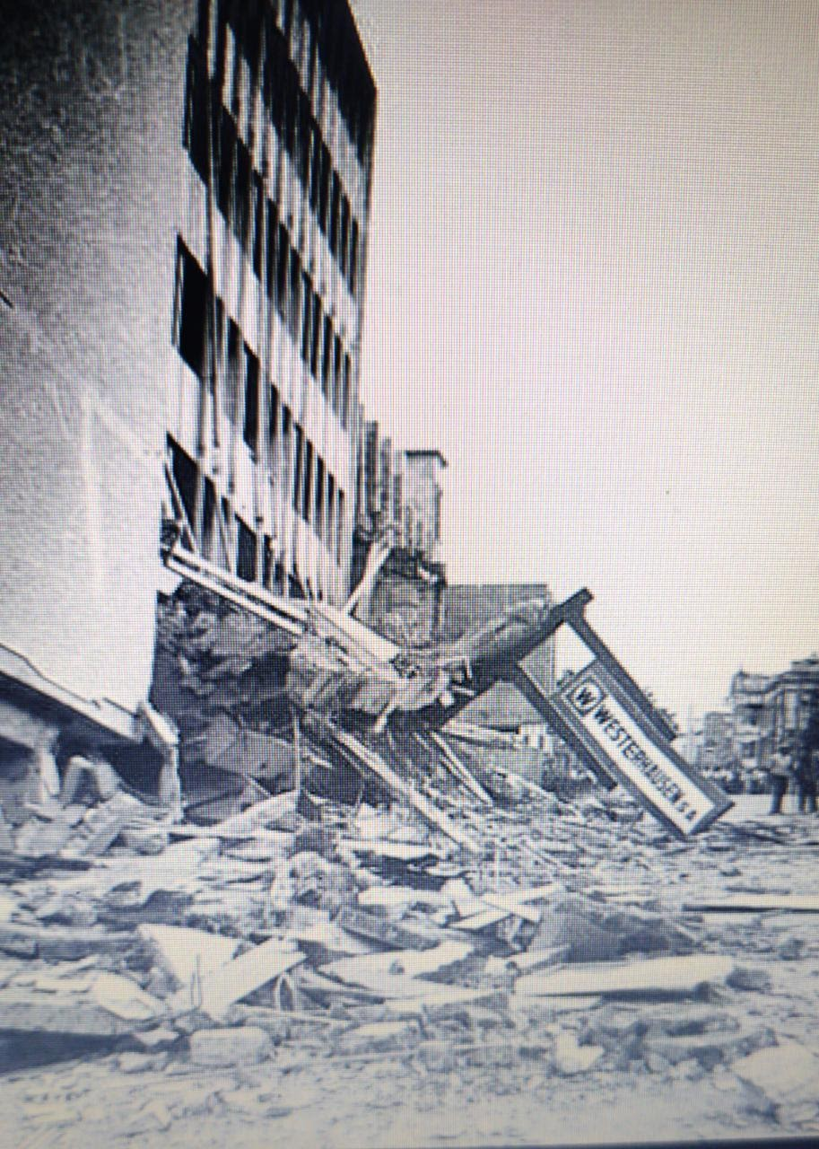

 An earthquake (also known as a quake, tremor or temblor) is the shaking of the surface of the Earth resulting from a sudden release of energy in the [Earth](https://en.wikipedia.org/wiki/Earth)'s [lithosphere](https://en.wikipedia.org/wiki/Lithosphere) that creates [seismic waves](https://en.wikipedia.org/wiki/Seismic_wave). Earthquakes can range in size from those that are so weak that they cannot be felt to those violent enough to propel objects and people into the air, and wreak destruction across entire cities. The [seismicity](https://en.wikipedia.org/wiki/Seismicity), or seismic activity, of an area is the frequency, type, and size of earthquakes experienced over a period of time. The word *tremor* is also used for [non-earthquake seismic rumbling](https://en.wikipedia.org/wiki/Episodic_tremor_and_slip).

At the Earth's surface, earthquakes manifest themselves by shaking and displacing or disrupting the ground. When the [epicenter](https://en.wikipedia.org/wiki/Epicenter) of a large earthquake is located offshore, the seabed may be displaced sufficiently to cause a [tsunami](https://en.wikipedia.org/wiki/Tsunami). Earthquakes can also trigger [landslides](https://en.wikipedia.org/wiki/Landslide) and occasionally, volcanic activity.

In its most general sense, the word *earthquake* is used to describe any seismic event—whether natural or caused by humans—that generates seismic waves. Earthquakes are caused mostly by rupture of geological [faults](https://en.wikipedia.org/wiki/Fault_(geology)) but also by other events such as volcanic activity, landslides, mine blasts, and [nuclear tests](https://en.wikipedia.org/wiki/Underground_nuclear_testing). An earthquake's point of initial rupture is called its [hypocenter](https://en.wikipedia.org/wiki/Hypocenter) or focus. The [epicenter](https://en.wikipedia.org/wiki/Epicenter) is the point at ground level directly above the hypocenter.

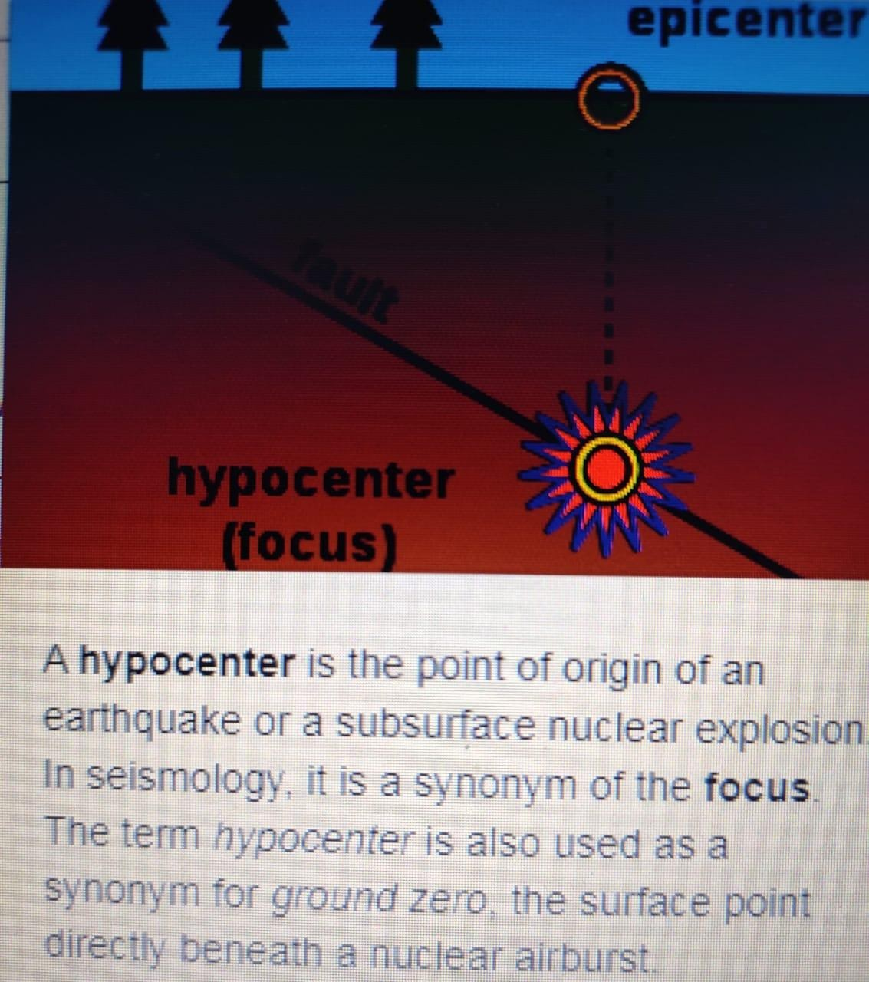

QUESTIONS:

* 1. Write two synonyms of earthquake.

ANS------------------------------------------------------------------------

* 1. Seismic waves are formed by the -------------------of ----------due to sudden release of ---------------------.
  2. How TSUNAMI is related with earthquake?

ANS-----------------------------------------------------------------------------------------------------------------

-------------------------------------------------------------------------------------------------

* 1. All the causes of earthquake mentioned here tabulate them in natural and man-made causes.

ANS--------------------------------------------------------------------------------------------------------------------------------------------------------------------------------------------------------------------------------------------------------------------------------------------------------------

* 1. Describe the term hypocenter , epicenter and fault in respect to earthquake.

ANS-------------------------------------------------------------------------------------------------------------------------------------------------------------------------------------------------------

**CHAPTER- 16 : LIGHT**

**TEST ITEM -1. Reflection of light**

|  |
| --- |
|  |
| **Description of Item**  Sameer, a student of class VIII went for watching a movie in a cinema hall. There he observed the screen of the hall is white in colour and is rough enough. |

Q.1.Do you think that making the screen rough helps in seeing the images clearly? Give reason.

Ans…………………………………………………………………………………………………………………………………………………

Q.2.Do you think that the laws of Reflection is valid for diffused reflection also?-Give reason.

Ans…………………………………………………………………………………………………………………………………………………………………………………………………………………………………………………………………………………………………………

Q.3.If two mirrors are kept at right angle with each other, how many images will be formed?

Ans…………………………………………………………………………………………………………………………………………………………………………………………………………………………………………………………………………………………………………

Q.4.After sunset, for sometimes there exists some light. Where from we get this light?

Ans:……………………………………………………………………………………………………………………………………………………………………………………………………………………………………………………………………………

**TEST ITEM -2- Dispersion of light**

|  |
| --- |
| **Description of Item**  Sometimes after the rain in clear sky Rainbow appears. Where we get to see seven colours in the form of a bow. |

Q.1.What is the name of the phenomena because of which white light gets separated into 7 colours?

Ans…………………………………………………………………………………………………………………………………………………………………………………………………………………………………………………………………………………………………………

Q.2.Why rain is an important factor in the formation of Rainbow?

Ans……………………………………………………………………………………………………………………………………………………………………………………………………………………………………………………………………………………………………

Q.3.If a white light passes through a rectangular glass slab, will the white light get separated into different colours?

Ans…………………………………………………………………………………………………………………………………………………

Q.4.If the white is replaced by a yellow light, will you observe the separation?

Ans:………………………………………………………………………………………………………………………………………………

**TEST ITEM -3-Reflection of light**

When a light ray strikes a surface separating two media with different optical properties, part of the light energy is reflected back to the media where it coming from. When light strikes a perfectly reflecting surface, such a mirror for example, all the light energy is reflected.

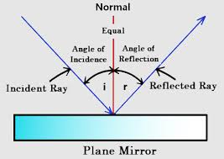

The surface separating the two media is called the interface or boundary.  
The point at which the incident ray strikes the interface is called the point of incidence.  
i is the angle made by the incident ray and the normal to the interface and is called the angle of incidence.  
r is the angle made by the reflected ray and the normal to the interface and is called the angle of reflection.  
  
Laws of reflection  
(1) The incident light ray, the reflected light ray and the normal to the interface at the point of incidence make a plane called the plane of incidence  
(2) The angle of incidence and the angle of reflection have the same size.

----------------------------------------------------------------------------------------------------------------------------------------

Q.1. A light ray strikes a reflective plane surface at an angle of 56° with the surface.  
a) Find the angle of incidence.  
b) Find the angle of reflection.  
c) Find the angle made by the reflected ray and the surface.  
d) Find the angle made by the incident and reflected rays.

Q.2. A ray of light is reflected by two parallel mirrors (1) and (2) at points A and B. The ray makes an angle of 25° with the axis of the two mirrors.

B

250

A

a) What is the angle of reflection at the point of incidence A?  
b) What is the angle of reflection at the point of incidence B?:

**TEST ITEM -4- EYE DONATION**

Zack and Sherah, donor and donor mom

Sherah was living in Guyana, a country on South America’s North Atlantic coast, when she gave birth to Zack. Complications during labour and delivery caused Zack to have cerebral palsy, which left him unable to communicate verbally and with severe breathing issues. Seeking better medical treatment, Sherah and Zack moved to New York City when he was three. Despite the improved conditions, Zack passed away at age nine due to complications associated with his disorder. Sherah was asked if she wanted Zack to be a donor. She had never thought about donation, but consented anyway in the midst of her grief. Zack was a smiley child who loved life and people, but his physical limitations left Sherah feeling unsure of how he would be able to contribute. She knows now that Zack was able to make a big impact through eye and tissue donation.

1.1 What is the correct time for the donation of eyes after death?

Tick the correct answer

1. Any time after death
2. Eye donation must be within 4 – 6 hours after death.
3. Before crimination.
4. After 24 hours of death

1.3. Which part of the damaged eye can restore through eye donation?

A. Retina of the eye

B. Lens of the eye

C. Cornea of the eye

D. Iris of the eye

**TEST ITEM-5**

**Understanding BRAILE SCRIPT**

Braille code, employing six embossed dots evenly arranged in rectangular letter spaces or cells, constitutes the dominant touch reading or typing system for the blind. Limited to 63 possible dot combinations per cell, there are a number of application examples, such as mathematics and sciences, and assistive technologies, such as braille displays, in which the 6-dot cell braille is extended to 8-dot. This work proposes a language-independent methodology for the systematic development of an 8-dot braille code. Moreover, a set of design principles is introduced that focuses on: achieving an abbreviated representation of the supported symbols, retaining connectivity with the 6-dot representation, preserving similarity on the transition rules applied in other languages, removing ambiguities, and considering future extensions. The proposed methodology was successfully applied in the development of an 8-dot literary Greek braille code that covers both the modern and the ancient Greek orthography, including diphthongs, digits, and punctuation marks.

Q 1.1: Name the Person who has discovered Braille system?

Q.1.3: Write answer in Yes/No as per given passage:

1. An extension of 8-dot braille work proposes a language-independent methodology for the systematic development of code.
2. The proposed methodology was successfully applied in the development of an 8-dot literary Indian braille code.

Q 1.4: How 8-dot Braille system used ? Explain.

**TEST ITEM -6**

**Understanding Kaleidoscope**

Kaleidoscope, optical device consisting of mirrors that reflect images of bits of coloured glass in a symmetrical geometric design through a viewer. A simple kaleidoscope consists of two thin, wedge-shaped mirror strips touching along a common edge or of a single sheet of bright aluminum bent to an angle of 60° or 45°. The mirrors are enclosed in a tube with a viewing eyehole at one end. At the other end is a thin, flat box that can be rotated; it is made from two glass disks, the outer one ground to act as a diffusing screen. In this box are pieces of coloured glass, tinsel, or beads. When the box is turned or tapped, the objects inside tumble into an arbitrary grouping, and when the diffusing screen is illuminated, the six-fold or eightfold multiplication creates a striking symmetrical pattern. The number of combinations and patterns is effectively without limit. The incline of the two mirrors inside a kaleidoscope determines the number of times the pattern created by the reflection of an object is repeated.

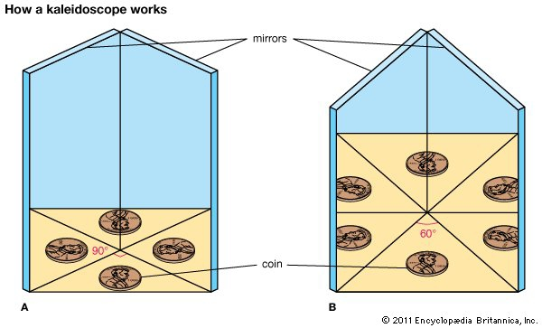Encyclopedia Britannica, Inc.



Q 1.1: What is Science behind Kaleidoscope?

Q 1.2: Basic principle of Kaleidoscope is ?

1. Laws of Reflection.
2. Laws of Scattering.
3. Laws of dispersion
4. Laws of reflection and White light is the combination of VIBGYOR.

Q.1.3: Write answer in Yes/No as per given passage:

(i)If the mirrors are positioned at a right angle, four images of the object can be seen.

(ii) If the mirrors' surfaces are positioned at 60°, nine images of the object appear.

Q 1.4: How does multiple reflection occur in Kaleidoscope ? Explain.

* **COMPLETE YOUR HOLIDAY HOMEWORK.**
* **ENJOY YOUR VACATION.**
* **TAKE GOOD CARE OF YOUR HEALTH AND HYGIENE.**😊😊

**SUBJECT TEACHER:**

**AKANKSHA SHARMA.**