K.V. Kendriya Vidyalaya Dul Hasti Project Kishtwar

HOLIDAY HOMEWORK

SUBJECT : SCIENCE

**CLASS: 7TH**

**SYLLABUS COMPLETED:- Syllabus Has been Completed.**

**ACADEMICS TASK:**

**Revision of TERM II SYLLABUS TILL LAST CHAPTER:-**

**Chapter11**: Transportation in Animals and Plants.

**Chapter12**: Reproduction in Plants.

**Chapter13**: Motion and Time.

**Chapter14**: Electric Current and its Effects.

**Chapter15**: Light.

**Chapter16**: Wastewater Story

Revise these above chapters and practice by writing.

* **All students have to complete the exercise (question answers) of each chapter in their SCIENCE homework copies.**
* **LEARNERS DAIRY: Make your Learners dairy for all the above chapters if not done .**
* **The written part should be done neatly in your handwriting in homework copy.**
* **READ , LEARN and REVISE all the above chapters thoroughly.**
* **Holiday homework, Assignment, Projects, Activities is a part of internal assessment so please do it carefully and well before time.**

**ACTIVITIES/ MODEL/Assignment:**

* Prepare Flash cards/ Telly Takies of any **Topic of your interest from above chapters.**( do not make the one iam sharing it is just for example).
* **For Example:-**

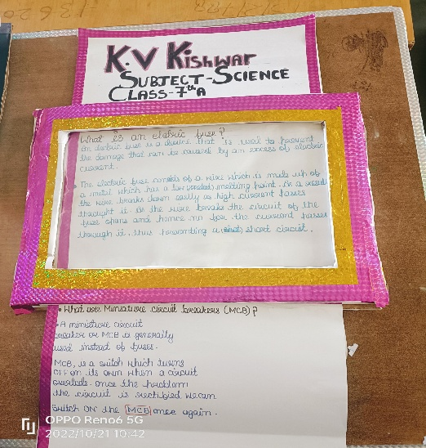

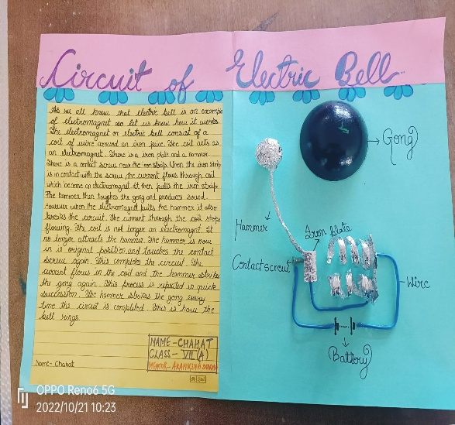

**CRITICAL AND CREATIVE THINKING TEST ITEMS**

**PUT SEPARATE CCT SCIENCE NOTEBOOK** .

* WRITE ALL THE CCT QUESTIONS ANSWER NEATLY AND IN WELL PRESENTED WAY IN YOUR CCT NOTEBOOK.

**CLASS VII SUB: SCIENCE CHAPTER-14 : ELECTRIC CURRENT AND ITS EFFECTS.**

**PRACTICE ITEM NO.1**

**CONDUCTORS AND INSULATORS**

**Conductors, Insulators, and Electron Flow**

The electrons of different types of atoms have different degrees of freedom to move around. With some types of materials, such as metals, the outermost electrons in the atoms are so loosely bound that they chaotically move in the space between the atoms of that material by nothing more than the influence of room-temperature heat energy. Because these virtually unbound electrons are free to leave their respective atoms and float around in the space between adjacent atoms, they are often called *free electrons*.

**Conductors vs Insulators**

In other types of materials such as glass, the atoms’ electrons have very little freedom to move around. While external forces such as physical rubbing can force some of these electrons to leave their respective atoms and transfer to the atoms of another material, they do not move between atoms within that material very easily.

This relative mobility of electrons within a material is known as electric *conductivity*. Conductivity is determined by the types of atoms in a material (the number of protons in each atom’s nucleus determines its chemical identity) and how the atoms are linked together with one another. Materials with high electron mobility (many free electrons) are called *conductors*, while materials with low electron mobility (few or no free electrons) are called *insulators*.

**Q1.1. Certain materials which have good relative mobility of electrons within them are called:**

**Q1.2. The chemical identity of an atom is determined by which particles**

**Q1.3. Identify insulators from amongst the list (Silver, Glass, Copper, Rubber)**

**Q1.4. Some materials experience changes in their electrical properties under different   
 conditions. Can you suggest an example for such material?**

**PRACTICE ITEM-2**

**Electron Flow / Electric Current**

While the normal motion of “free” electrons in a conductor is random, with no particular direction or speed, electrons can be influenced to move in a coordinated fashion through a conductive material. This uniform motion of electrons is what we call *electricity* or *electric current*. To be more precise, it could be called *dynamic electricity* in contrast to *static electricity*, which is an unmoving accumulation of electric charge. Just like water flowing through the emptiness of a pipe, electrons are able to move within the empty space within and between the atoms of a conductor. The conductor may appear to be solid to our eyes, but any material composed of atoms is mostly empty space! The liquid-flow analogy is so fitting that the motion of electrons through a conductor is often referred to as a “flow.”

A noteworthy observation may be made here. As each electron moves uniformly through a conductor, it pushes on the one ahead of it, such that all the electrons move together as a group. The starting and stopping of electron flow through the length of a conductive path is virtually instantaneous from one end of a conductor to the other, even though the motion of each electron may be very slow. An approximate analogy is that of a tube filled end-to-end with marbles:

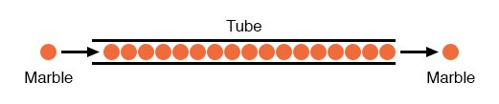Figure 2.7

The tube is full of marbles, just as a conductor is full of free electrons ready to be moved by an outside influence. If a single marble is suddenly inserted into this full tube on the left-hand side, another marble will immediately try to exit the tube on the right. Even though each marble only traveled a short distance, the transfer of motion through the tube is virtually instantaneous from the left end to the right end, no matter how long the tube is. With electricity, the overall effect from one end of a conductor to the other happens at the speed of light: a swift 186,000 miles per second!!! Each individual electron, though, travels through the conductor at a *much* slower pace.

**Electron Flow Through Wire**

If we want electrons to flow in a certain direction to a certain place, we must provide the proper path for them to move, just as a plumber must install piping to get water to flow where he or she wants it to flow. To facilitate this, *wires* are made of highly conductive metals such as copper or aluminum in a wide variety of sizes.

Remember that electrons can flow only when they have the opportunity to move in the space between the atoms of a material. This means that there can be electric current *only* where there exists a continuous path of conductive material providing a conduit for electrons to travel through. In the marble analogy, marbles can flow into the left-hand side of the tube (and, consequently, through the tube) if and only if the tube is open on the right-hand side for marbles to flow out. If the tube is blocked on the right-hand side, the marbles will just “pile up” inside the tube, and marble “flow” will not occur. The same holds true for electric current: the continuous flow of electrons requires there be an unbroken path to permit that flow. Let’s look at a diagram to illustrate how this works:

unbroken electron flowFigure 2.8

A thin, solid line (as shown above) is the conventional symbol for a continuous piece of wire. Since the wire is made of a conductive material, such as copper, its constituent atoms have many free electrons which can easily move through the wire. However, there will never be a continuous or uniform flow of electrons within this wire unless they have a place to come from and a place to go. Let’s add a hypothetical electron “Source” and “Destination:”

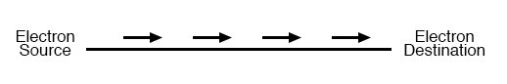Figure 2.9

Now, with the Electron Source pushing new electrons into the wire on the left-hand side, electron flow through the wire can occur (as indicated by the arrows pointing from left to right). However, the flow will be interrupted if the conductive path formed by the wire is broken:

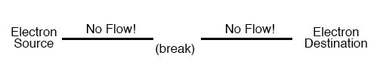Figure 2.10

**Q2.1. The flow of water in an empty pipe can be drawn as an analogy to :**

**Q2.2. A continuous path of conductive material providing a conduit for electrons to   
 travel through is commonly referred to as**

1. **Electric circuit**
2. **Flow of charges**
3. **Both A and B**
4. **None of the above**

**Q2.3. In figure 2.10 what does break represent**

1. **Non-availability of charged particles**
2. **Break in the continuity of the conductive material**
3. **A complete electric circuit**
4. **All the above**

**Q2.4. An electric component that makes or breaks an electric circuit is commonly referred to as:**

**PRACTICE ITEM-3**

**ELECTRIC COMPONENTS AND CIRCUITS**

Krishna accompanied his father to an electrical repair shop, where he was excited to see so many different types of electrical elements, equipments, appliances and their internal parts. He was so curious that he started asking about each of them to his father and the electrician present there.

He got to know that cell is one of the sources of electricity and when many cells are connected in series then batteries are formed, which gives more electricity.Rahul had learnt about series connection in his VII science textbook, so he could relate to it and understood the concept.

He started playing and made a small electrical circuit as shown below using the material present in shop.

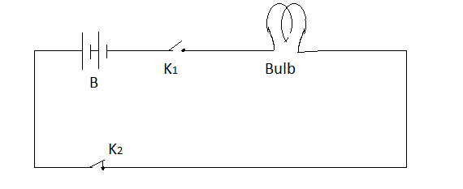

Q 3.1 Krishna wonders why the bulb in above circuit does not glow and he writes down the possible causes he could think of

1. Key K1 is open iii) Filament of bulb is broken
2. Circuit is incomplete iv) Key K2 is open

Choose the correct option for why bulb was not glowing from below

1. (i) and (iv) b) (iii) and (iv) (c) (i),(ii) and (iii). (d) (ii) and (iv)

Q3.2 How many cells are connected in above circuit to form battery B.

1. One (ii) Two (iii) Three (iv) Four

Which of the following is correct way of connecting cells to form a battery?

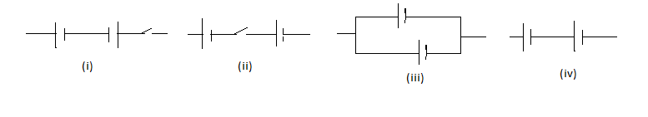

Q 3.3 Electrician advised Krishna not to touch a lighted bulb when connected to the mains and only to use cells for activities. Suggest due to which of the following reasons Rahul was advised not to touch bulb when connected to main supply.

1. Bulb may be hot (iii) May get electrical shock
2. Hand may get burnt badly (iv) Bulb will burst
3. (i) & (ii) (b) (ii) & (iii) (c) (iii) & (iv) (d) (i), (ii) & (iii)

**DIRECTION OF ELECTRIC CURRENT**

**PRACTICE ITEM NO.4**

)

**.**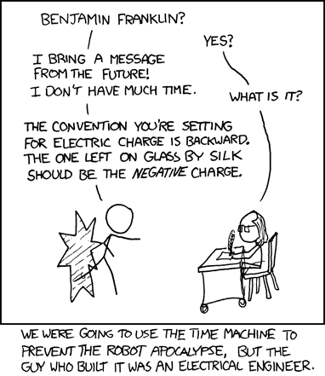

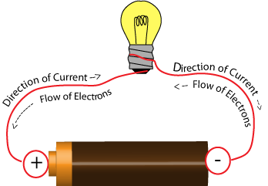

Electric Current :The direction of the current is defined as the direction of the moving positive charge, or, the direction of the electric field which always points from high potential to low potential. The unit of the electric current is Ampere in the SI system.

Q4.1. From the above figure it is clearly evident that the suggested flow of current by   
 convention is from:

Q4.2. Thedirection taken opposite to the direction of current by convention is

1. Flow of positively charged particles
2. Flow of negatively charged particles
3. Flow of neutral particles
4. Flow of atoms

Q4.3The S.I. unit of electric current is

1. Altmeter
2. Ampere
3. Avagadro number
4. Coulomb

Q4.4. A living creature that turns itself into the living battery

1. STARFISH
2. SHARK
3. EEL
4. OCTOPUS

**HEATING EFFECT OF ELECTRIC CURRENT.**

**PRACTICE ITEM NO.5**

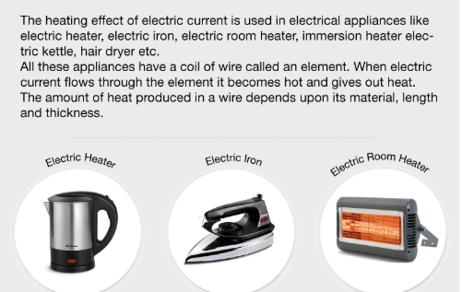

Source: Google search

Q. 5.1. The above electric appliances are based on :

A. Heating effect of electric current.

B. Magnetic effect of electric current.

C. Mechanical effect of electric current

D. Chemical effect of electric current.

Q. 5.2. In devices like electric iron the process of temperature regulation is done by

A. Fuse wire. B. Conducting wire. C. Bimetallic strip.

D. Circuit breaker.

**Q. 5.3.** Electric fuse is based on the principle of heating effect of electric current. The fuse wire used in a circuit should melt and break there by breaking the circuit. Based on the statement it can be concluded about a fuse wire that:

A. A fuse wire should allow large amount of current to pass through.

B. A fuse wire should have high melting point.

C. A fuse wire should have low melting point.

D. A fuse wire should be an insulator.

* 1. Both A and B are correct (ii) Only B and D are correct

1. Both B and C are correct (iv) Except C all are incorrect

Q. 5.4. The filament bulb is such that the inner core filament is heated up to a certain temperature after which it is illuminated. The metal that is generally used to make the filament of the bulb is:

A. COPPER B. CHROMIUM C. TITANIUM D. TUNGSTEN

**6. SHORT CIRCUITING AND FIRE ACCIDENTS**

**QUESTION 6(6.1-6.4)**

**PRACTICE ITEM NO.6**

Mumbai: The devastating fire at 'Make in India' event in Mumbai on 14 February 2016 was apparently caused due 'electrical short circuit'.The investigation report of the Maharashtra fire department - accessed by the CNN-IBN – hinted negligence towards the organizers for ignoring safety norms while laying the electrical cables especially under the main stage.The report also slammed the event organizer for keeping inflammable materials carelessly beneath the stage, which includes adhesive, paint, varnish and LPG cylinder.

After examining the place of incident, the fire officials found that the electrical spark came in contact with these combustible materials including LPG cylinders and aggravated the situation."The LPG cylinder in the vicinity burst after coming in contact with the fire and it leaked the entire stage quickly due to high wind speed," the report said. Earlier, Maharashtra Chief Minister Devendra Fadnavis, who was present at a function at the 'Make in India' event, ordered an investigation into the fire. CNN-IBN earlier reported that electrical short circuit could be the reason behind the incident.

A common type of short circuit occurs when the positive and negative terminals of a [battery](https://en.wikipedia.org/wiki/Battery_(electricity)) are connected with a low-[resistance](https://en.wikipedia.org/wiki/Electrical_resistance) [conductor](https://en.wikipedia.org/wiki/Electrical_conductor), like a [wire](https://en.wikipedia.org/wiki/Wire). With a low resistance in the connection, a high [current](https://en.wikipedia.org/wiki/Current_(electricity)) will flow, causing the delivery of a large amount of [energy](https://en.wikipedia.org/wiki/Energy) in a short period of time.

A high current flowing through a battery can cause a rapid increase of temperature, potentially resulting in an explosion with the release of [hydrogen](https://en.wikipedia.org/wiki/Hydrogen) gas and [electrolyte](https://en.wikipedia.org/wiki/Electrolyte) (an [acid](https://en.wikipedia.org/wiki/Acid) or a [base](https://en.wikipedia.org/wiki/Base_(chemistry))), which can burn tissue and cause blindness or even death. Overloaded wires will also [overheat](https://en.wikipedia.org/wiki/Overheating_(electricity)) causing damage to the wire's insulation, or starting a fire. High current conditions may also occur with [electric motor](https://en.wikipedia.org/wiki/Electric_motor) loads under stalled conditions, such as when the impeller of an electrically driven [pump](https://en.wikipedia.org/wiki/Pump) is jammed by debris; this is not a short, though it may have some similar effects.

In electrical devices unintentional short circuits are usually caused when a wire's [insulation](https://en.wikipedia.org/wiki/Electrical_insulation) breaks down, or when another conducting material is introduced, allowing charge to flow along a different path than the one intended

* 1. . What may be the main cause of short circuit?

1. Direct touching of wires as insulation of wires may come off due to wear and tear
2. Connection of many devices to a single circuit.
3. Use of insulation tape
4. Use of substandard switch
   1. Which of the following components are safety devices used in electrical circuit?
5. Fuse ii) Bulb

iii) Miniature Circuit Breaks (MCBs) iv) Indicator light

Choose the correct option

1. i) & iv) b) ii) & iv) c) i) & iii) d) iii) & iv)
   1. From the following pictures identify fuse.

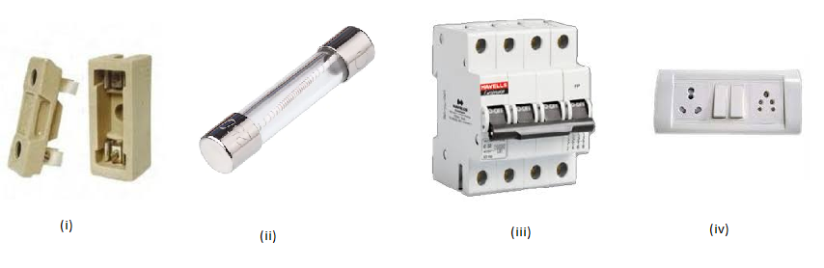

1. (i) & (iii) b) (i) & (ii) c) (ii) & (iii) d) (iii) & (iv)
   1. Scientific concept behind the working of a fuse wire is
2. Division of current in series connection
3. Magnetic effect of electric current.
4. Flow of current through conductor.
5. Heating effect of electric current.

**ELECTROMAGNETS**

**PRACTICE ITEM NO.7**

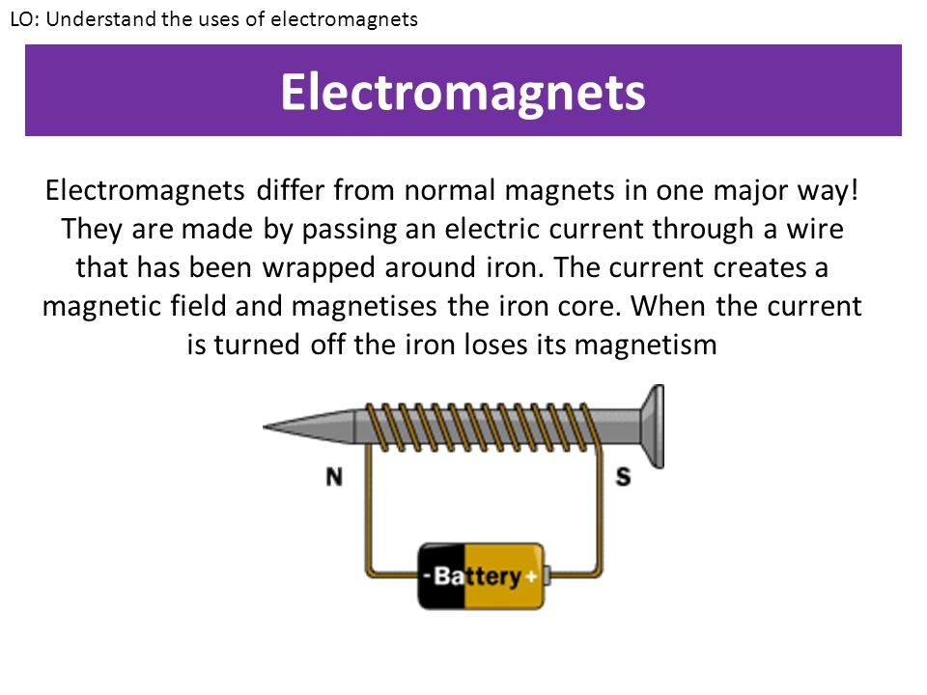

**7.1.** The magnetic effect of electric current was first discovered by

A. BENJAMIN FRANKLIN

B. HANS CHRISTIAN OERSTED

C. HENRY TESLA

D. ALBERT EINSTIEN

**7.2** The most common electric device we use which is based on magnetic effect of electric current is

A. Electric bell

B. Filament bulb

C. LED bulb

D. Electric oven

**7.3** The commercial application of electromagnets is widely used in :

**8. ELECTRIC BELL**

**PRACTICE ITEM NO.8**

**QUESTION 8(8.1-8.4)**

An **electric bell** is a mechanical or electronic [bell](https://en.wikipedia.org/wiki/Bell_(instrument)) that functions by means of an [electromagnet](https://en.wikipedia.org/wiki/Electromagnet). When an [electric current](https://en.wikipedia.org/wiki/Electric_current) is applied, it produces a repetitive buzzing, clanging or ringing sound. Electric bells have been widely used at [railroad crossings](https://en.wikipedia.org/wiki/Level_crossing), in [telephones](https://en.wikipedia.org/wiki/Telephone), [fire](https://en.wikipedia.org/wiki/Fire_alarm) and [burglar alarms](https://en.wikipedia.org/wiki/Burglar_alarm), as [school bells](https://en.wikipedia.org/wiki/School_bell), [doorbells](https://en.wikipedia.org/wiki/Doorbell), and alarms in industrial plants, since the late 1800s, but they are now being widely replaced with electronic sounders. An electric bell consists of one or more electromagnets, made of a coil of insulated wire around an [iron bar](https://en.wikipedia.org/wiki/Magnetic_core), which attract an iron strip [armature](https://en.wikipedia.org/wiki/Armature_(electrical_engineering)) with a clapper. When an electric current flow through the coils, the electromagnet creates a magnetic field which pulls the armature towards it, causing the hammer to strike the bell.

The most widely used form is the interrupter bell, which produces a continuous sound when current is applied. See animation, above. The bell or [gong](https://en.wikipedia.org/wiki/Gong) *(B)*, which is often in the shape of a cup or half-sphere, is struck by a spring-loaded arm *(A)* with a metal ball on the end called a [clapper](https://en.wikipedia.org/wiki/Bell_(instrument)), actuated by an [electromagnet](https://en.wikipedia.org/wiki/Electromagnet) *(E)*. In its rest position the clapper is held away from the bell a short distance by its springy arm. When the switch *(K)* is closed, an [electric current](https://en.wikipedia.org/wiki/Electric_current) passes from the [battery](https://en.wikipedia.org/wiki/Battery_(electric)) *(U)* through the winding of the electromagnet. It creates a [magnetic field](https://en.wikipedia.org/wiki/Magnetic_field) that attracts the iron arm of the clapper, pulling it over to give the bell a tap. This opens a pair of [electrical contacts](https://en.wikipedia.org/wiki/Electrical_contact) *(T)* attached to the clapper arm, interrupting the current to the electromagnet. The magnetic field of the electromagnet collapses, and the clapper springs away from the bell. This closes the contacts again, allowing the current to flow to the electromagnet again, so the magnet pulls the clapper over to strike the bell again. This cycle repeats rapidly, many times per second, resulting in a continuous ringing.

The tone of the sound generated depends on the shape and size of the bell or gong resonator. Where several bells are installed together, they may be given distinctive rings by using different size or shapes of gong, even though the strike mechanisms are identical.

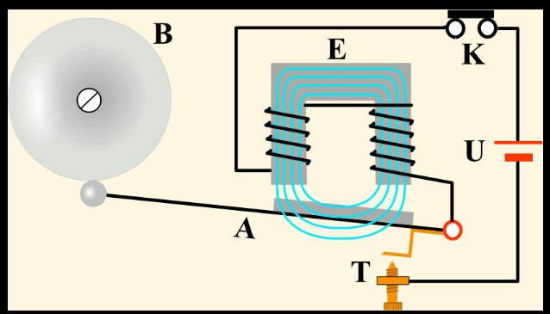

FIGURE 8 A

8.1. An electric bell uses

A. A permanent magnet B. An electromagnet

C. A Bar Magnet D. A cylindrical magnet

**8.2. ON** passing electric current the hammer gets attracted towards the gong due to:

A. the strong bar magnet placed in the appliance

B. the coils behaves like a magnet as magnetic field is induced upon passing electric current in the coil

C. the weight of the hammer makes it strike the gong

D. the gong is a strong magnet.

8.3. If the metallic gong is replaced by a plastic or wooden gong then what would be the effect of the sound produced by the bell.

8.4. If we increase the number of turns around the coil, what would be the effect on the electromagnet:

A. its magnetic property increases

B. its magnetic property decreases

C. its magnetic property does not change

D. the coil becomes a permanent magnet

**9. ELECTRIC SHOCK PREVENTION AND SAFETY**

**QUESTION 9(9.1-9.4)**

**PRACTICE ITEM NO.9**

As electric current is conducted through a material, any opposition to that flow of electrons (resistance) results in a dissipation of energy, usually in the form of heat. This is the most basic and easy-to-understand effect of electricity on living tissue: current makes it heat up. If the amount of heat generated is sufficient, the tissue may be burnt. The effect is physiologically the same as damage caused by an open flame or other high-temperature source of heat, except that electricity has the ability to burn tissue well beneath the skin of a victim, even burning internal organs.

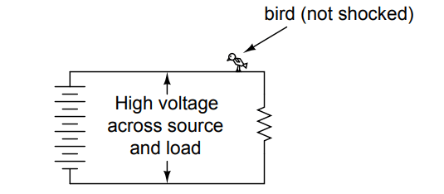

**FIGURE 9 A**

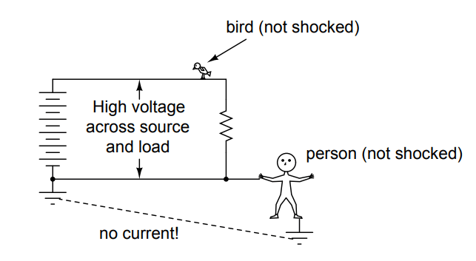

**X**

**FIGURE 9 B**

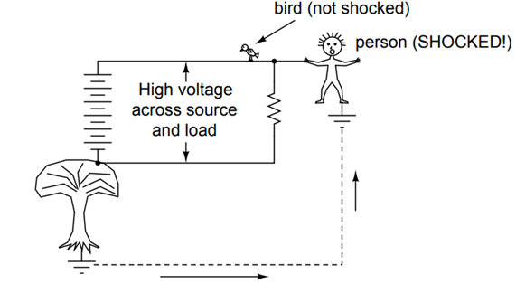

**FIGURE 9 C**

9.1 In **FIGURE 9A** why birds did not get electric shock_______?

A. The birds body acts as a conductor hence allows a steady path to the flow of charges through it

B. Without two contact points on the body for current to enter and exit, respectively, there is no hazard of shock

C. There is not enough potential difference in the wire in contact with the bird to cause electrocution.

D. The air acts as insulator and prevents electric shock.

9.2. The best possible protective gear a person could use among the options which would minimize the risk of electric shock.

1. Hand or foot contact, insulated with rubber.
2. Foot contact through leather shoe sole (dry)
3. Foot contact through leather shoe sole (wet).
4. All are equally useful to minimize the risk of electric shock

9.3. In **FIGURE 9 C** the person gets electric shock due to the following reasons

A. Accidental ground path through tree (touching wire) completes the circuit for shock current   
 through the victim.

B. The person acts as a conductor allowing current through him resulting in electric shock.

C. There is huge amount of potential difference in the wire in contact with the person to   
 cause electrocution.

D. The air acts as a conductor and causes electric shock.

**9.4.** In **figure 9 B ‘X’ re**presents

A. Fuse wire

B. Earthing

C. Switch

D. Cell

**CHAPTER-15 : LIGHT**

**PRACTICE ITEMS- 1 LIGHT- LENS [TOTAL POINT-10]**

A lens is a transparent piece of glass or plastic with at least one curved surface. It gets its name from the Latin word for "lentil" (a type of pulse used in cooking), but don't let that confuse you. There's no real reason for this other than that the most common kind of lens (called a convex lens) looks very much like a lentil.

A lens works by **refraction**: it bends light rays as they pass through it so they change direction. That means the rays seem to come from a point that's closer or further away from where they actually originate—and that's what makes objects seen through a lens seem either bigger or smaller than they really are.

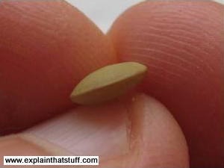

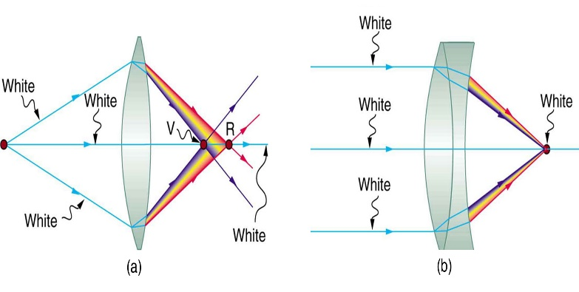

[This Photo](https://courses.lumenlearning.com/austincc-physics2/chapter/26-6-aberrations/) by Unknown Author is licensed under [CC BY](https://creativecommons.org/licenses/by/3.0/)

**Q1**. What is the basic principle of working of lens?

[A] Reflection

[B] Refraction

[C] Diffraction

[D] Scattering

**Types of lenses**

**PRACTICE ITEM NO.2**

There are two main types of lenses, known as convex (or converging) and concave (or diverging).

**Convex lenses :-** In a **convex lens** (sometimes called a positive lens), the glass (or plastic) surfaces bulge outwards in the center giving the classic lentil-like shape. A convex lens is also called a converging lens because it makes parallel light rays passing through it bend inward and meet (converge) at a spot just beyond the lens known as the **focal point**.

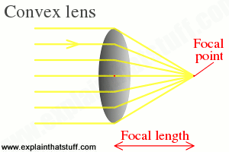

The nature , size and type of image varies with position in case of convex lens.

Convex lenses are used in things like [telescopes](https://www.explainthatstuff.com/spacetelescopes.html) and [binoculars](https://www.explainthatstuff.com/binoculars.html) to bring distant light rays to a focus in your eyes. It’s also used in magnifying glass and microscope.

**Concave lenses**

A **concave lens** is exactly the opposite with the outer surfaces curving inward, concave lens is thinner in the middle than at the edges, so it makes parallel light rays’ curve outward or diverge. That's why concave lenses are sometimes called diverging lenses.

The image formed by concave image is always virtual, erect and smaller than object.

Concave lenses are used in things like [TV projectors](https://www.explainthatstuff.com/projectiontv.html) to make light rays spread out into the distance.

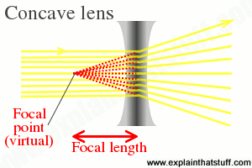

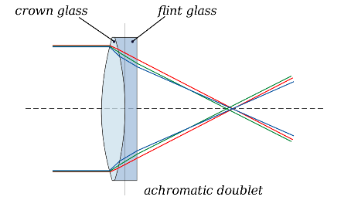

[This Photo](https://en.wikipedia.org/wiki/Achromatic_telescope) by Unknown Author is licensed under [CC BY-SA](https://creativecommons.org/licenses/by-sa/3.0/)

Compound lenses

It's possible to make lenses that behave in more complex ways by combining convex and concave lenses. A lens that uses two or more simpler lenses in this way is called a **compound lens**

**Q2.** Convex lens is called converging lens because:

[A] It shows refraction

[B] It bends light inwards

[C] Because refracted rays meet at a point

[D] Forms large image

**Q3**.?One student performed the activity to form image of sun on paper as shown in picture. The paper started burning.

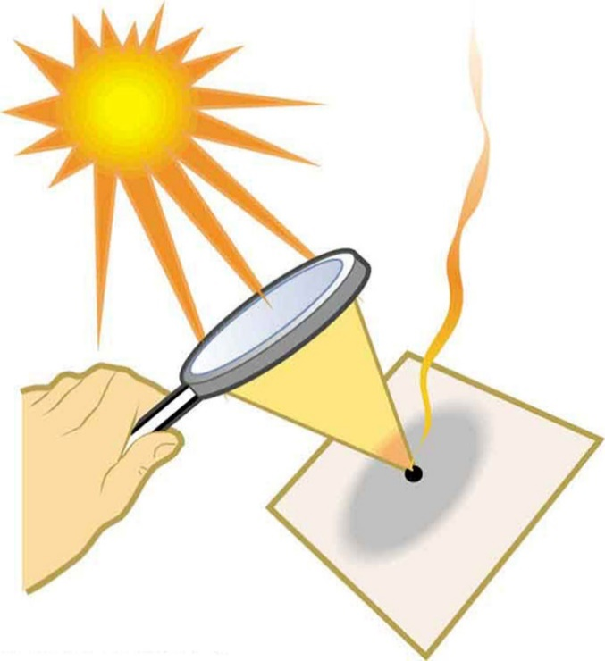

[This Photo](https://courses.lumenlearning.com/boundless-physics/chapter/lenses/) by Unknown Author is licensed under [CC BY-SA](https://creativecommons.org/licenses/by-sa/3.0/)

(A) Which lens he would have used in experiment?

(B) Why paper started burning?

**Q4**. There was a serious debate on the use of contact lens. After along research an authentic and famous medical research agency has published this article contact lens in the newspaper and magazine. After reading this article what is your opinion about use of contact lens : Use of contact lens should be ban or not? Justify.

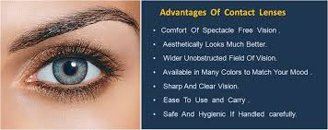

Ans. --------------------------------------------------------------------------------------------------------------------------------------------------------------------------------------------------------------------------------------------

**Q5. Tick the correct option:**

|  |  |  |  |  |  |
| --- | --- | --- | --- | --- | --- |
| S. No. | Statement | Strongly Agree | Agree | Disagree | Strongly disagree |
| 1 | Real image of a distant object only by concave lens. |  |  |  |  |
| 2 | Concave and convex lens can be distinguished by touch. |  |  |  |  |
| 3 | Concave lens has virtual focus |  |  |  |  |
| 4 | Convex lens may form both virtual and real image |  |  |  |  |

**PRACTICE ITEM 3– LIGHT (Total credit- 10)**

* Three students Ratnesh, Rohit and Monika were very curious to know how light comes from sun to us. They went to their teacher and asked the same. Teacher performed one activity before the students
* He has taken three cardboard squares of equal size. Located the center of each pieces of cardboard by drawing the diagonals.
* With the help of a nail, made a hole at the center of each cardboard. Now fixed the three card boards on plasticine or on stands so that they remain upright.
* Arranged the three card boards A, B and C, one behind the other such that their centers are in the same horizontal line. You can pass a knitting needle through the holes to confirm if they are in a straight line.
* Now place a burning candle in front of the board C and look through the pinhole in board A. The flame will be clearly visible. This shows that light travels in a straight line. Now, move board B slightly and again look through the pinhole in board A as shown in the figure.

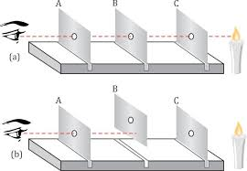

* After this teacher has disturbed the position of one card board and they were not able to see the candle.

Q. 2.1 **. From the above activity what is the path of light:**

a) Curved

b) Bend

c) Like wave

d) Straigh

**Q. 2.2. In the above activity Can we substitute card board with Glass sheet?**

Ans.----------------------------------------------------------------------------------------------------------------------------------------------------------------------------------------------------------------------------------------------

Q. 2.3. After the first part of the activity, teacher has disturbed the position of one card board. Would you be able to see candle? Justify your answer.

Ans. --------------------------------------------------------------------------------------------------------------------------------------------------------------------------------------------------------------------------------------------

**PRACTICE ITEM 4- LIGHT**

Light travels in a straight line and reflects back, if falls on a shiny surface like mirror. This is why, one can see image in a mirror. Surface of mirror and position of object from the mirror decides the type of image. If the light falls on a plane surfaced mirror, image size will be equal to object. If light falls on a convex surfaced mirror, diminished image forms. If light falls on a concave surfaced mirror, image form can be larger or smaller in size than the object.

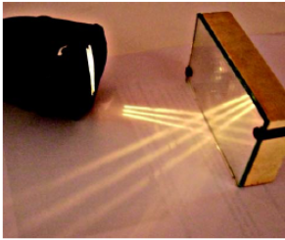

**Q.1-.** Image is formed by bouncing back of light by-

1. Rough surface 2. Shiny surface 3. Absorbing surface 4. Reflecting surface
2. 1&2
3. 2&4
4. 3&4
5. 1&4

**Ques2** Answer is Yes/No

Light falling on a convex lens is diverged

.(Hint: See the figure given)

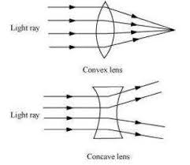

YES/NO

Q. Why is AMBULANCE written inverted in Ambulance vans?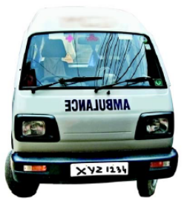

**_______________________________________________________________________________________________________________________________________________________________________________________________________________________________________________________________**

**UNIT-1**

**Mirror Writing**

**Mirror writing** is formed by writing in the direction that is the reverse of the natural way for a given language, such that the result is the [mirror image](https://en.wikipedia.org/wiki/Mirror_image) of normal writing: it appears normal when it is reflected in a [mirror](https://en.wikipedia.org/wiki/Mirror). It is sometimes used as an extremely primitive form of [cipher](https://en.wikipedia.org/wiki/Cipher). A common modern usage of mirror writing can be found on the front of [ambulances](https://en.wikipedia.org/wiki/Ambulance), where the word "AMBULANCE" is often written in very large mirrored text, so that drivers see the word the right way around in their [rear-view mirror](https://en.wikipedia.org/wiki/Rear-view_mirror).

Some people are able to produce handwritten mirrored text. Notably, [Leonardo da Vinci](https://en.wikipedia.org/wiki/Leonardo_da_Vinci) wrote most of his personal notes in this way. Mirror writing [calligraphy](https://en.wikipedia.org/wiki/Calligraphy) was popular in the [Ottoman Empire](https://en.wikipedia.org/wiki/Ottoman_Empire), where it often carried mystical associations.

[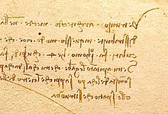](https://en.wikipedia.org/wiki/File:Da_Vinci_mirror_writing.jpg)

(The notes on [Leonardo da Vinci](https://en.wikipedia.org/wiki/Leonardo_da_Vinci)'s famous [Vitruvian Man](https://en.wikipedia.org/wiki/Vitruvian_Man) image are in mirror writing.)

[Leonardo da Vinci](https://en.wikipedia.org/wiki/Leonardo_da_Vinci) wrote most of his personal notes in mirror, only using standard writing if he intended his texts to be read by others. The purpose of this practice by Leonardo remains unknown, though several possible reasons have been suggested. For example, writing left-handed from left to right would have been messy because the ink just put down would smear as his hand moved across it. Writing in reverse would prevent such smudging. An alternative theory is that the process of rotating the linguistic object in memory before setting it to paper, and rotating it before reading it back, is a method of reinforcement learning. From this theory, it follows the use of [boustrophedon writing](https://en.wikipedia.org/wiki/Boustrophedon), especially in public codes, may be to render better recall of the text in the reader.

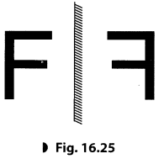**Q1.1**Reflection of Letter ‘F’ is shown in the figure. Which letter will be seen as it is in the reflection if seen in a plane mirror?

1. L
2. C
3. M
4. Q

**Q.1.2**- Why convex mirror is used as rare view mirror but not the plane mirror?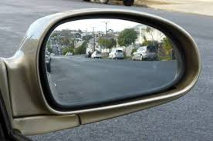

1. A plane mirror has a less wide field of view.
2. Plane mirror forms images of the same size.
3. Convex mirror always forms erect and diminished image.
4. Plane mirror is costly.
5. Only i, is correct
6. Both i,ii are correct
7. All are correct
8. i,ii and iii are correct

Q.4 A student want to burn the paper by using mirror.

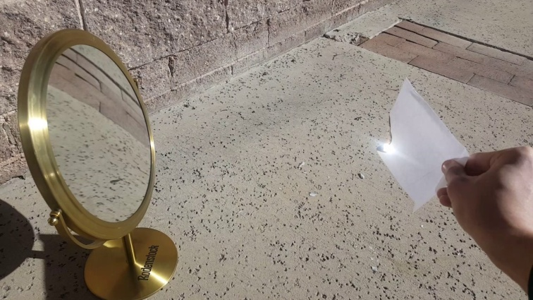

Which type of mirror should he select for this purpose?

a. Convex

b. Concave or Convex

c. Plane

d. Concave

**WING MIRROR**

A side view mirror or side mirror also known as a wing mirror , is a mirror placed on the exterior of motor vehicles for the purposes of helping the driver see areas behind and to the sides of the vehicle , outside the driver’s peripheral vision .

Almost all modern cars mount their side mirrors on the doors –normally at the A –pillar- rather than the wings (the portion of the body above the wheel well)

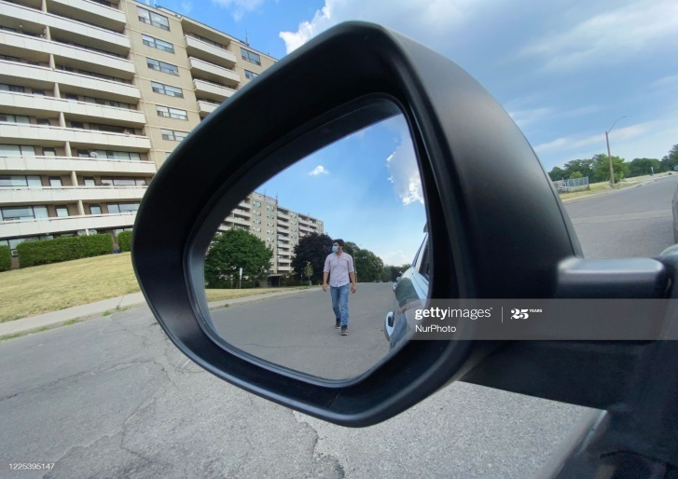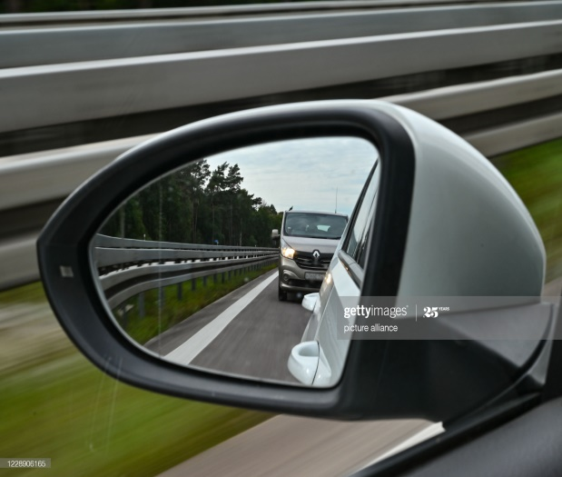

The side mirror is equipped for manual and remote vertical and horizontal adjustment so as to provide adequate coverage to drivers of different height and seated position

Q.1- In mirrors ,the back surface is coated with a thin layer of

1. Mercury
2. Silver
3. Red oxide
4. Silver nitrate

**PRACTICE ITEM 2– LIGHT (Total Items – 10**

When light ray passes through a prism, it shows refraction and dispersion. Some colours bend more than others as they pass through the prism due to refraction they split apart , this means that a beam of white light going into a prism, comes out as a spectrum of different colours , rainbows appear when rain drops in the air act like a prism , splitting sun light into different colours .

The separation of visible light into its different colours is known as dispersion. If white light is used, the prism splits up the light into a series of colours. These are – red, orange, yellow, green, blue, indigo and violet. The spread of colours is called a spectrum.

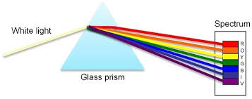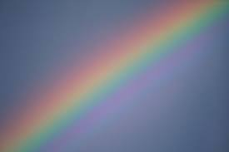

Q. 2.1 The splitting of white light into seven colours is known as-

a) Reflection

b) Refraction

c) Dispersion

d) Interference

* **COMPLETE YOUR HOLIDAY HOMEWORK.**
* **ENJOY YOUR VACATION.**
* **TAKE GOOD CARE OF YOUR HEALTH AND HYGIENE.**😊😊

**SUBJECT TEACHER:**

**AKANKSHA SHARMA.**