**K.V. Kendriya Vidyalaya Dul Hasti Project Kishtwar**

**WINTER HOLIDAYS HOMEWORK**

**SUBJECT : SCIENCE**

**CLASS: 6TH**

**SYLLABUS COMPLETED:- Syllabus Has been Completed fully.**

**ACADEMICS TASK:**

**Revision of TERM II SYLLABUS TILL LAST CHAPTER:-**

**Chapter9**: The Living Organisms and Their Surroundings

**Chapter10**: Motion and Measurement of Distances

**Chapter11**: Light, Shadows and Reflections

**Chapter12**: Electricity and Circuits

**Chapter13**: Fun with Magnets

**Chapter15**: Air Around us

Revise these above chapters and practice by writing.

* **All students have to complete the exercise (question answers) of each chapter in their SCIENCE homework copies.**
* **LEARNERS DAIRY: Make your Learners dairy for all the above chapters if not done.**
* **The written part should be done neatly in your handwriting in homework copy.**
* **READ , LEARN and REVISE all the above chapters thoroughly.**
* **Holiday homework, Assignment, Projects, Activities is a part of internal assessment so please do it carefully and well before time.**

**ACTIVITIES/ MODEL:**

**▪︎ ACTIVITY 1:** Make an **ASSIGNMENT** of 5 pages on **Topics in the chapter Air around us:-**

✓ What is air?

✓ Composition of Air.

✓ What are the Properties of Air .

Make a small diary and write down all important words for the chapter Air around us.

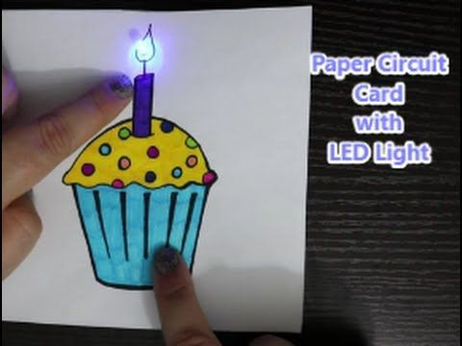

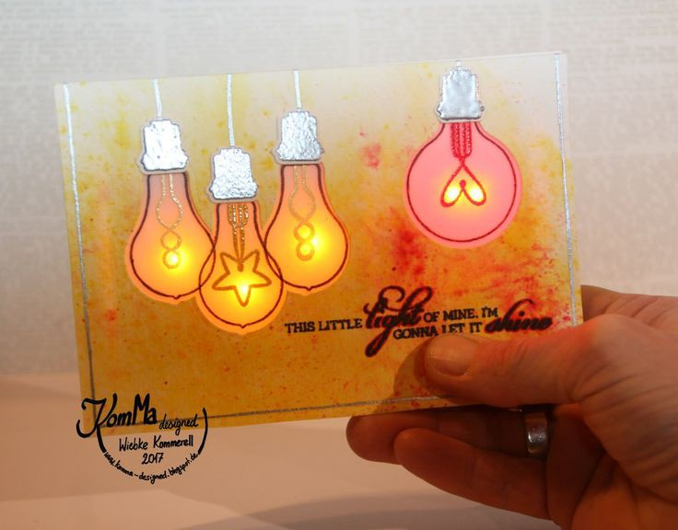▪︎ **ACTIVITY 2: To create a simple LED circuit card .( Make only one out of these ).  Some Examples are given below**

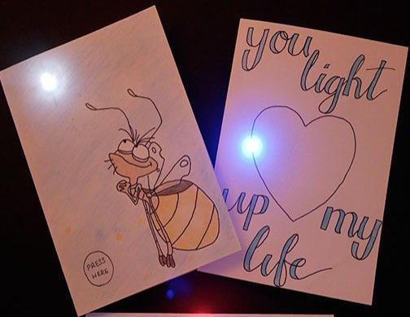

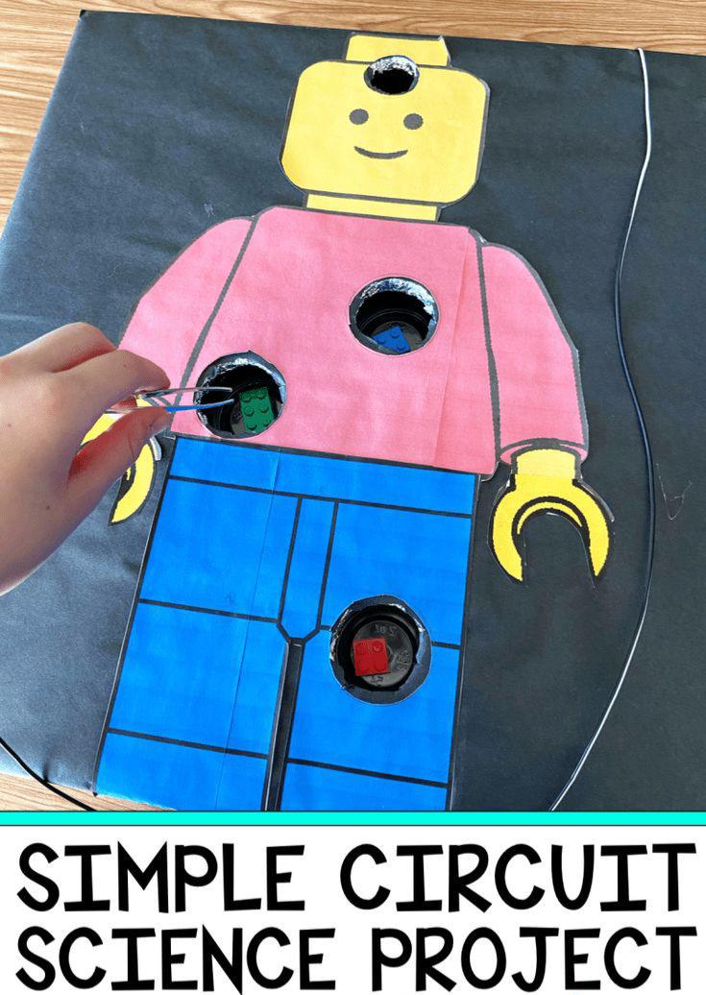

**ASSIGNMENT: FOR PRACTICE**

**DO These CCT a IN SCIENCE HOMEWORK NOTEBOOK.**

**CRITICAL AND CREATIVE THINKING TEST ITEMS**

**Chapter:13 Fun with Magnets.**

**Question 1:**

Bhawana witnessed an interesting game at the fair. A duck was floating in a tub. When a plate containing some grains of rice was brought close to the duck, the duck moved towards the plate. But, when a plate containing some pebbles was brought close to the duck, it moved away from the plate. Explain how this could have been possible.

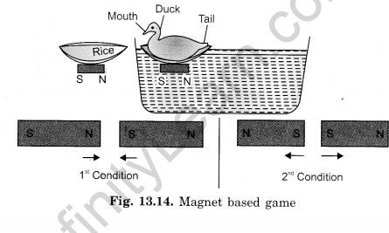  
**Question 2:**

Observe the pictures A and B given in figure carefully.

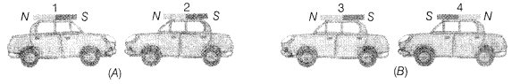  
Which of the following statements is correct for the above given pictures?  
(a) In A, cars 1 and 2 will come closer and in B, cars 3 and 4 will come closer.  
(b) In A, cars 1 and 2 will move away from each other and in B, cars 3 and 4 will move away.  
(c) In A, cars 1 and 2 will move away and in B, 3 and 4 will come closer to each other.  
(d) In A, cars 1 and 2 will come closer to each other and in B, 3 and 4 will move away from each other.

**Question 3:**

Boojho dipped a bar magnet in a heap of iron filings and pulled it out. He found that iron filings got stuck to the magnet as shown in figure.

(a) Which regions of the magnet have more iron filings sticking to it?

(b) What are these regions called?

**Chapter 15: Air around us**

**Question 1.**Garima observed that when she left her tightly capped bottle full of water in the open sunlight, tiny bubbles were formed all around inside the bottle. She was amazed and asked about this phenomenon to her science teacher.  
(a) Why Garima observed tiny bubbles inside the bottle?  
(b) What will happen to the bubbles if we bring it back to normal room temperature?  
(c) When do we see the above phenomenon in nature and what is its significance?  
(d) What values of Garima is shown here?

**Question 2.**While going for a local excursion to a deserted area, Vikas wore a mask. When boarding the school bus his friends made fun of him that he was looking odd and beside enjoying he is taking extra precautions. But when going through the dry roads all of his friends felt the need of the mask. He suggested everyone to tie handkerchief on their nose. It helped them a lot.  
(a) What is dust?  
(b) What are the health issues related with dust?  
(c) How does a mask help?  
(d) What values of Vikas is shown here?

**Question 3.**

To release some of the air from the bottle shown in the given diagram, we should:  
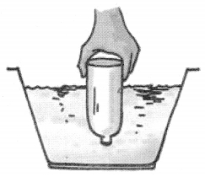  
(a) push the glass further down  
(b) tilt the glass  
(c) pour more water into the basin  
(d) blow bubbles into the glass

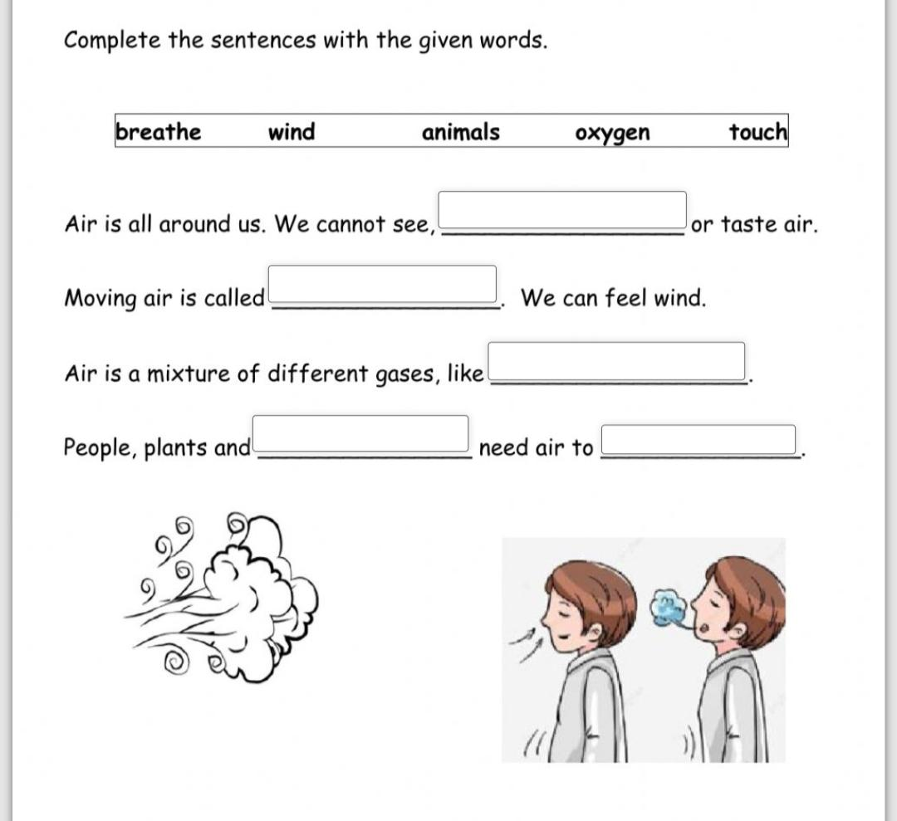

**Chapter: 11 Light , Shadow and Reflection.**

Classify the objects or materials given below as opaque, transparent or translucent and luminous or non-luminous. One has been done for you:  
air, water, a piece of rock, a sheet of aluminium, a mirror, a wooden board, a sheet of polythene, a CD, smoke, a sheet of plane glass, fog, a piece of red hot iron, an umbrella, a lighted fluorescent tube, a wall, a sheet of carbon paper, the flame of a gas burner, a sheet of cardboard, a lighted torch, a sheet of cellophane, a wire mesh, kerosene stove, sun, firefly, moon.  
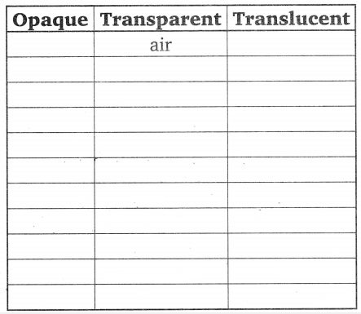  
D. Tick (œ“) the Correct Option:  
1. Shadows form because:  
(a) opaque objects reflect light  
(b) opaque objects do not allow light to pass through them  
(c) light travels in one direction from a source  
(d) light bends around an opaque object

2. objects do not allow any light to pass through them.  
(a) Transparent  
(b) Translucent  
(c) Opaque  
(d) Luminous  
3. Which of the following is a non-luminous body?  
(a) Moon  
(b) Sun  
(c) Bulb  
(d) Burning candle  
4. The colour of a shadow is :  
(a) black  
(b) green  
(c) grey  
(d) cannot say

E. Fill in the Blanks:  
1. Light is a form of ……………………. .  
2. A glowing tubelight is an example of …………………… source of light.  
3. The shadow of an object is always of ………………. colour.  
4. The …………………… is a luminous object.  
5. Light travels in a ……………….. line.

F. State True or False:  
1. The moon is a natural source of light. ……………….  
2. Light always travels in a straight line. ……………….  
3. Pinhole camera works on the principle of rectilinear propagation of light. ………………….  
4. Stars are luminous bodies. …………………  
5. Shadow of an object is formed in the direction. opposite to that of the light source. …………….  
  
 **COMPLETE YOUR HOLIDAY HOMEWORK.**

**ENJOY YOUR VACATION.**

**TAKE GOOD CARE OF YOUR HEALTH AND HYGIENE.**😊😊

**SUBJECT TEACHER:**

**AKANKSHA SHARMA.**



